1) Create VPC with 2 private and 2 public subnets

Creating a **VPC (Virtual Private Cloud)** with **2 public and 2 private subnets** is a common setup in AWS that supports high availability and separation of public-facing and internal resources

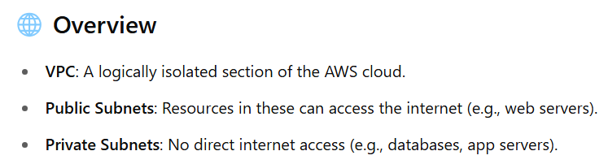

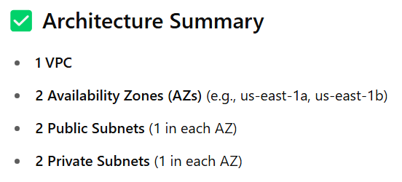

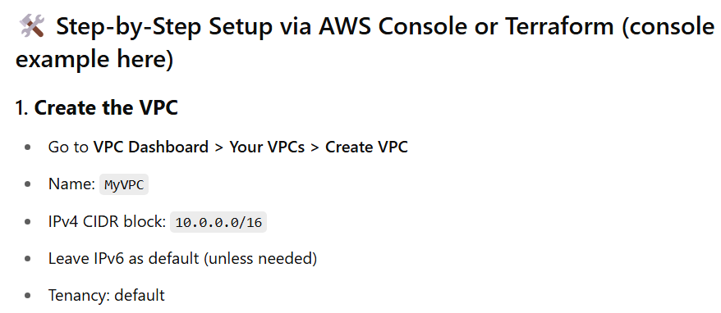

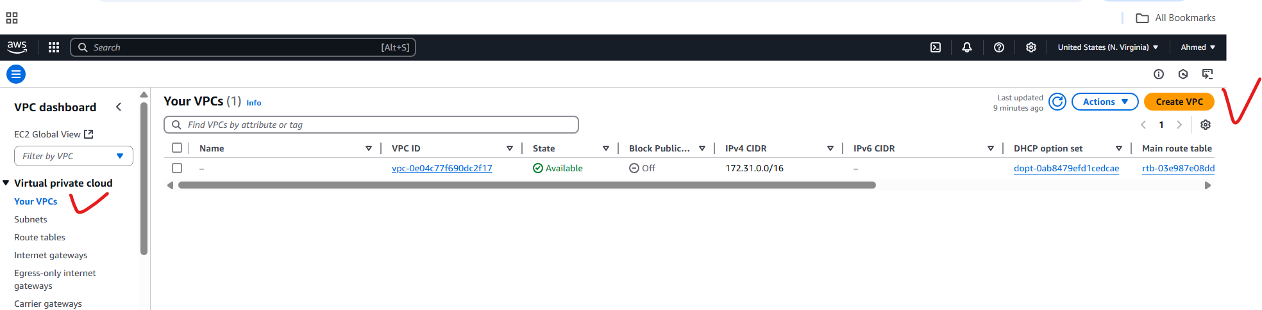

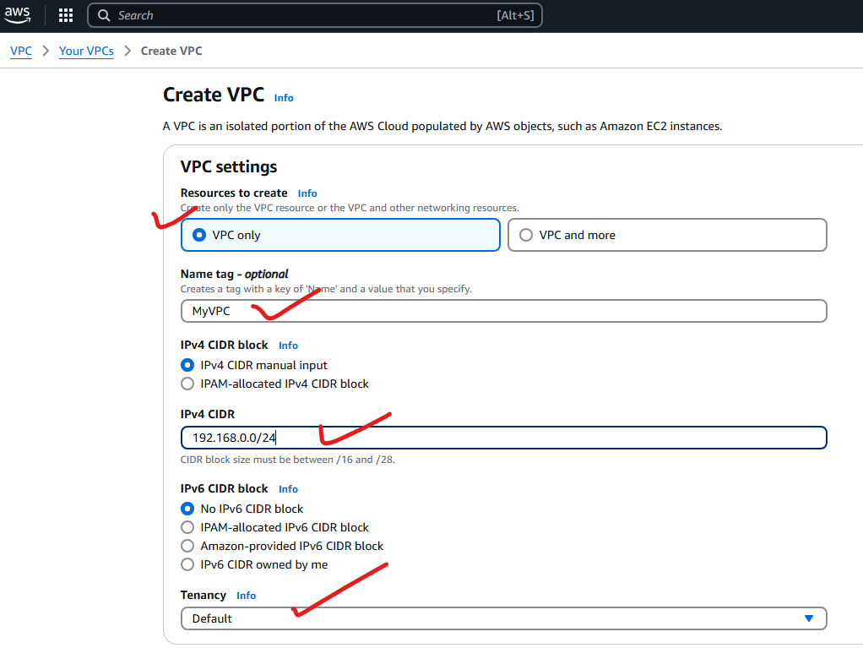

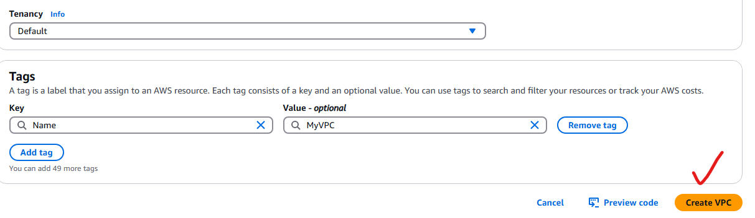

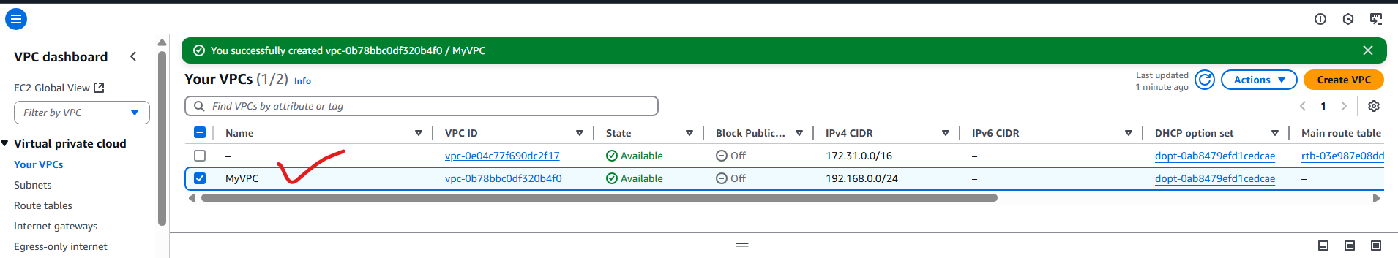

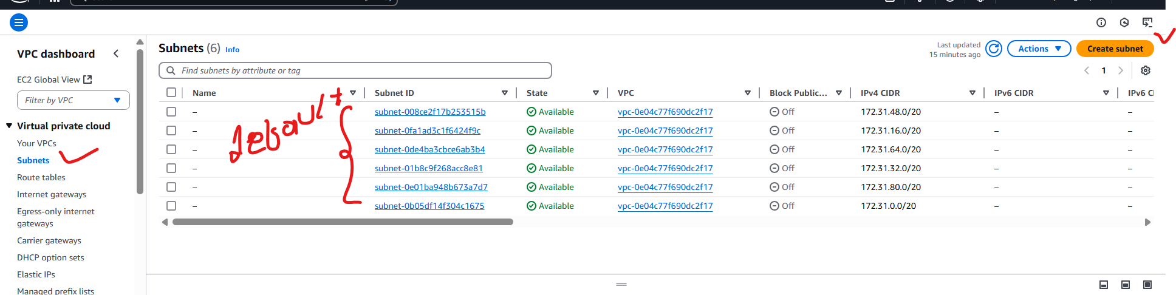

**Create Subnets:**

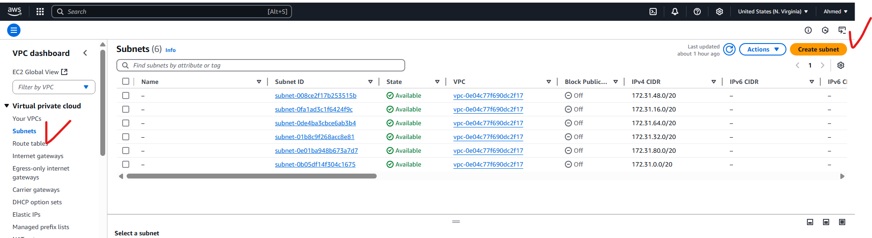

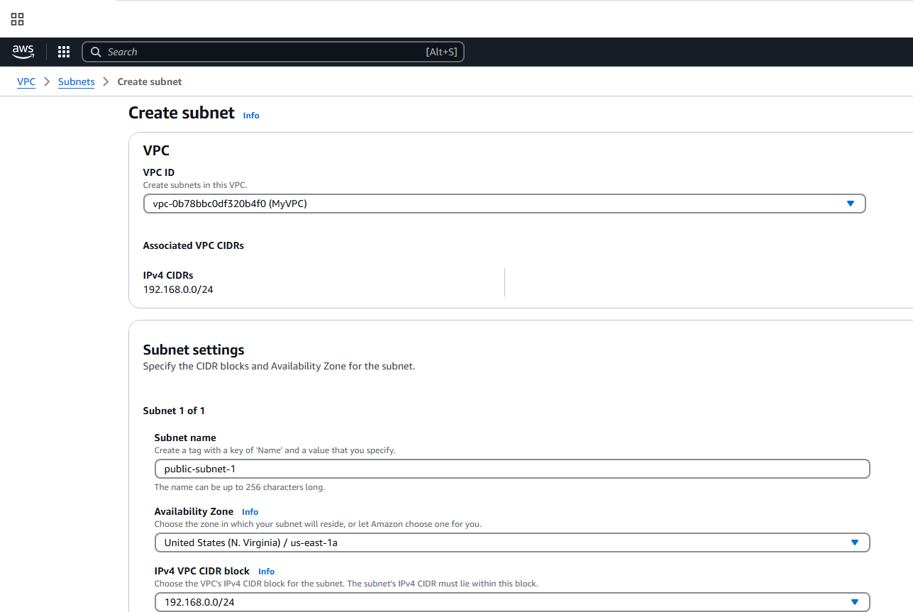

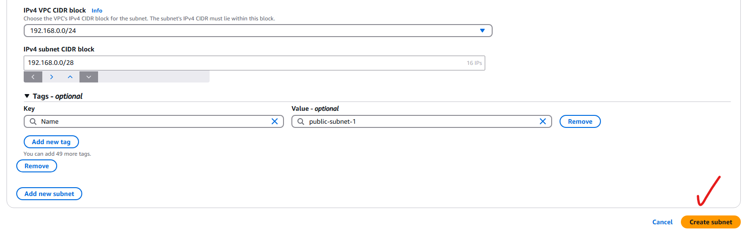

**Public-subnet-2**

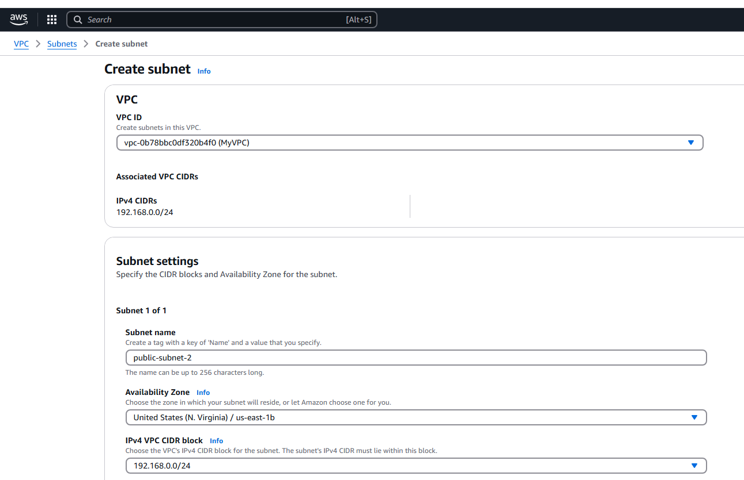

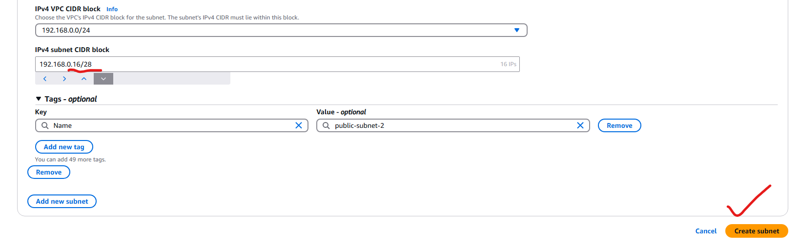

**Create private-subnet-1**

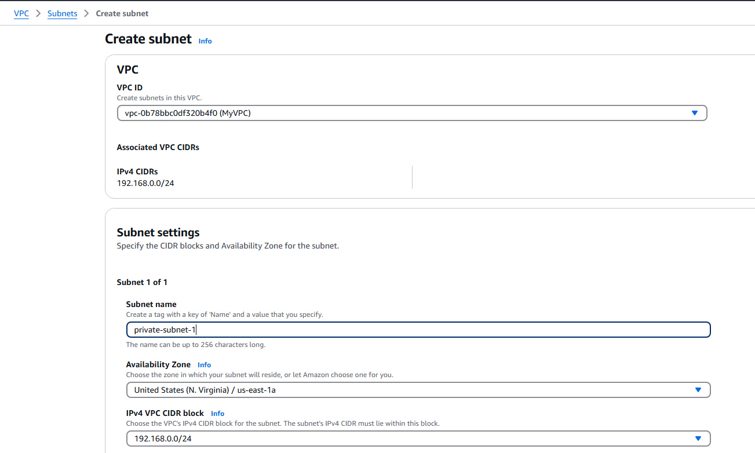

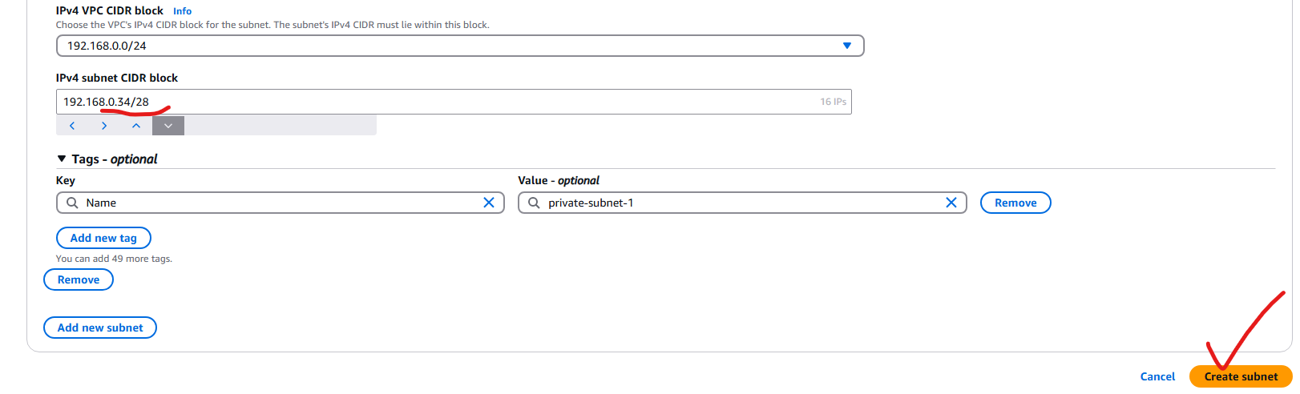

**Creating private-subnet-2**

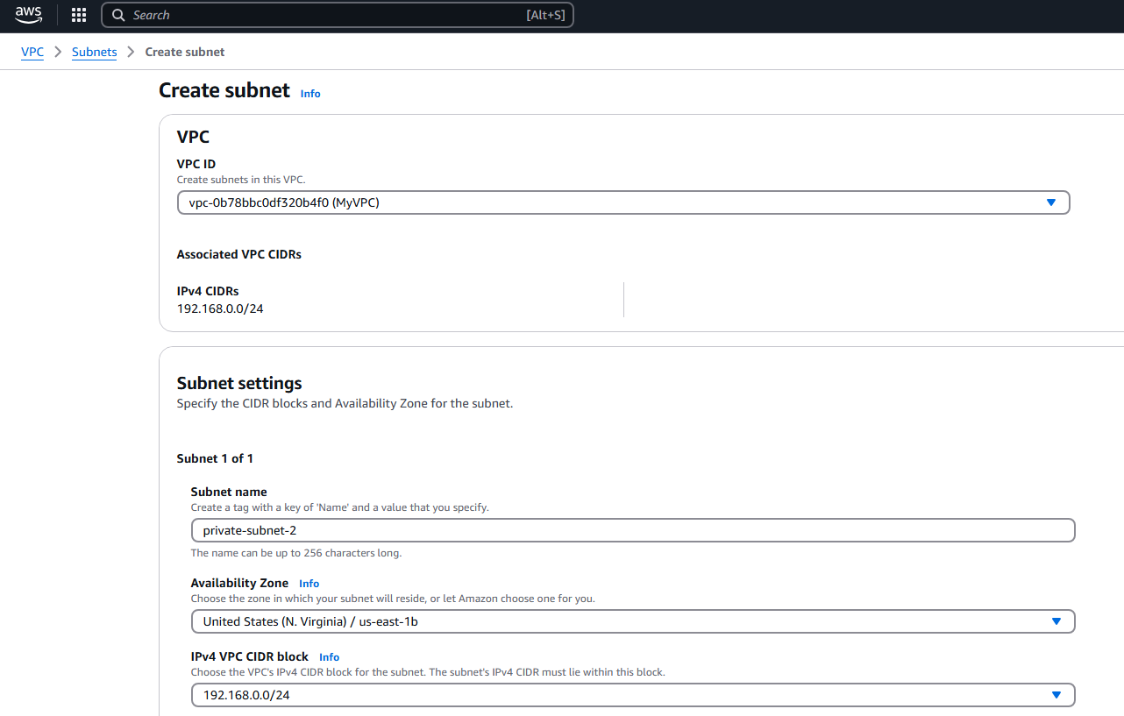

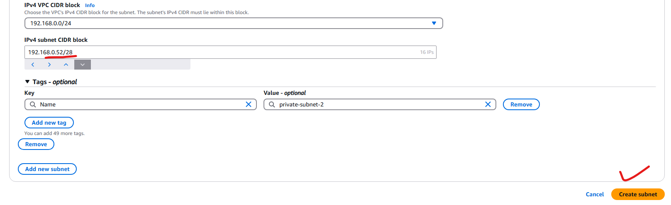

**Crated 2-public subnet and 2-private subnet.**

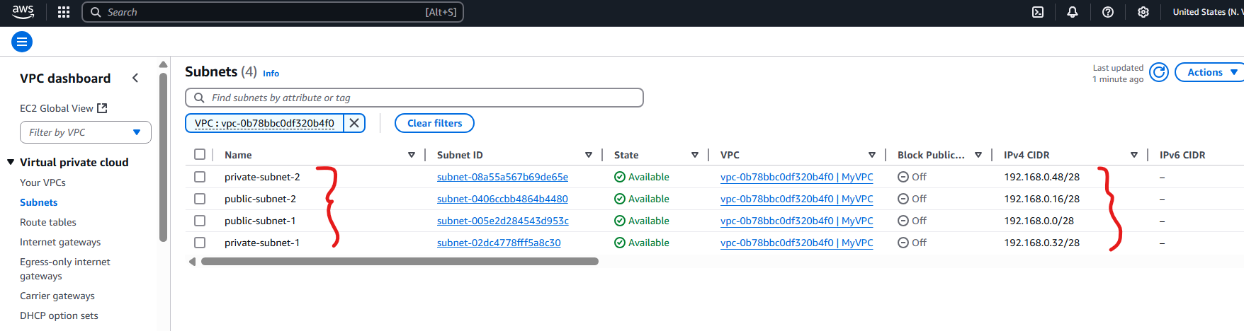

**2) Enable DNS Hostname in VPC**

To enable DNS hostnames in an already created VPC, follow the steps below using the AWS Console

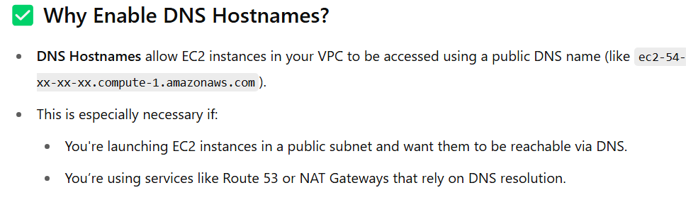

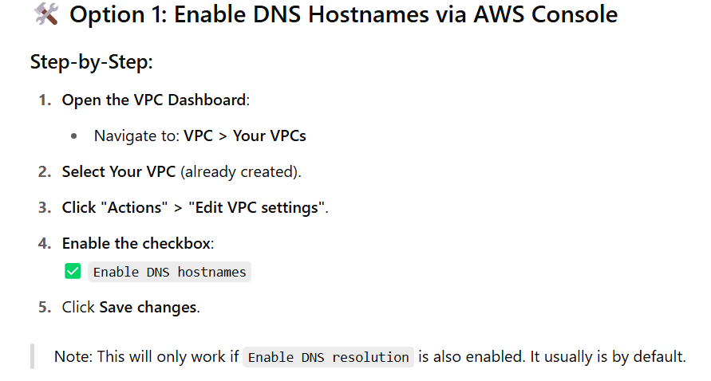

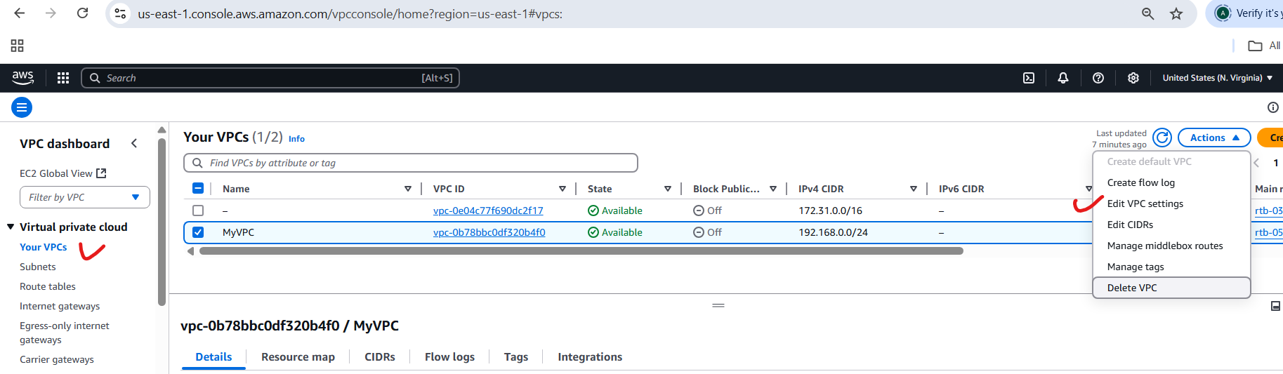

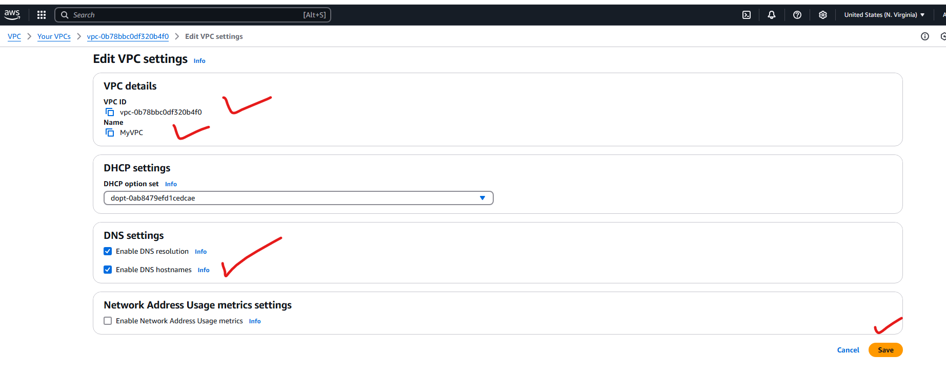

**3) Enable Auto Assign Public ip in 2 public subnets**



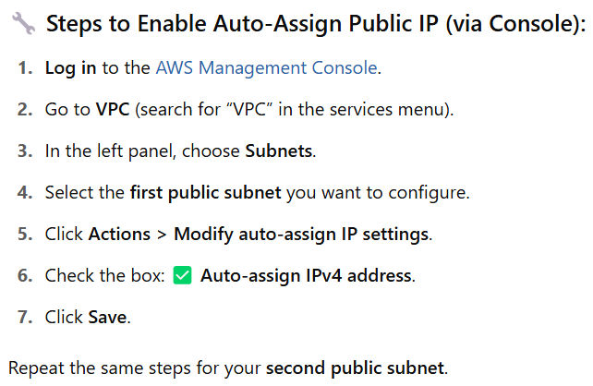

Edit subnet Setting



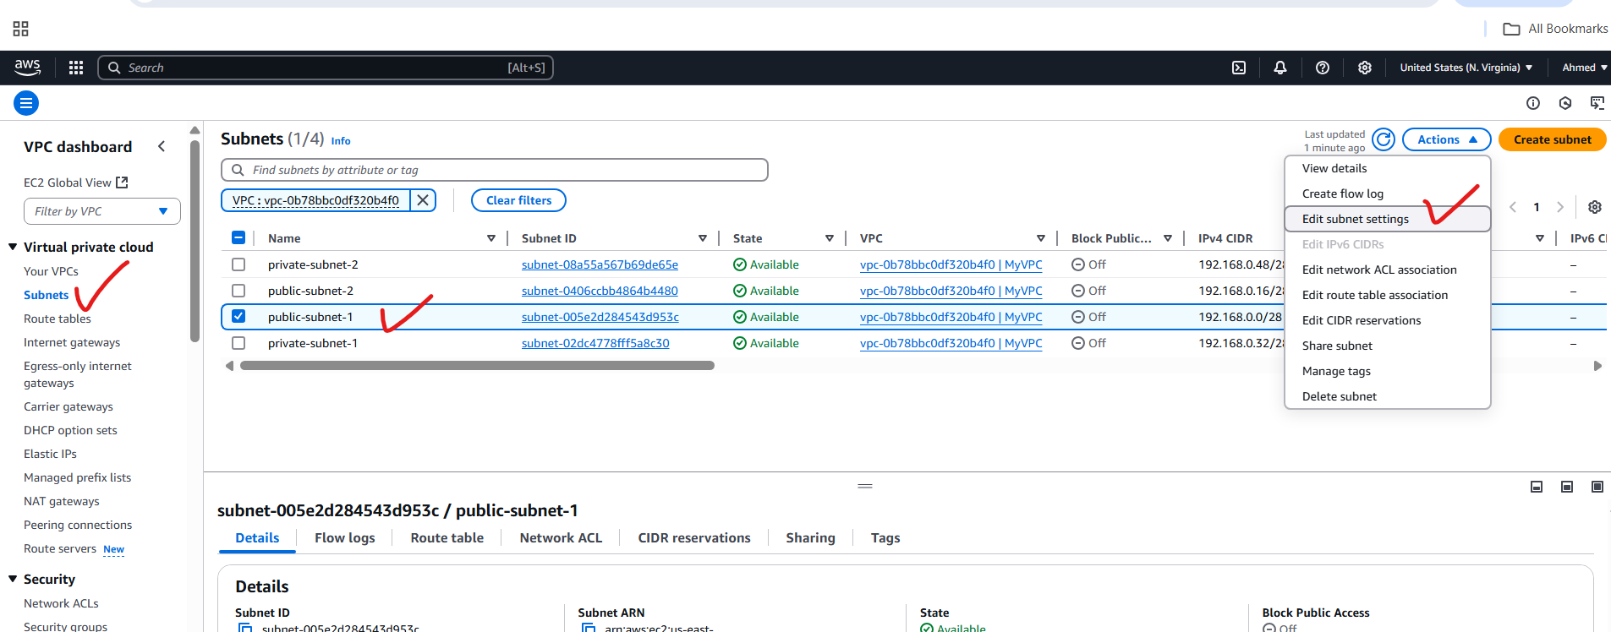

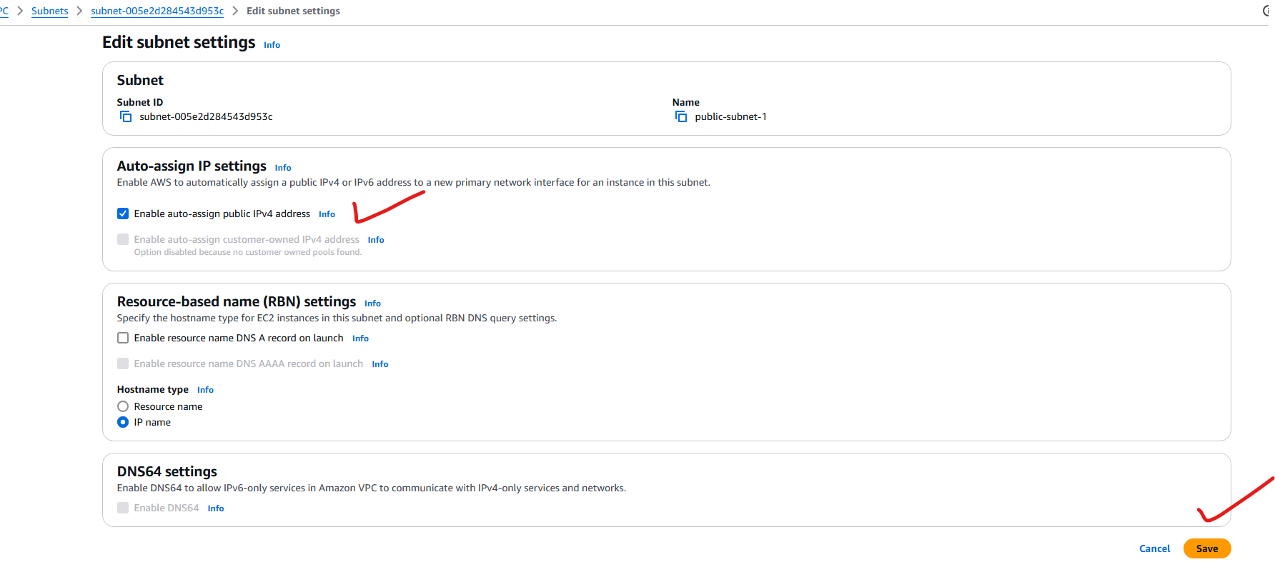

**4) Add 2 private subnets in private route table**

**Create or Identify the Private Route Table**

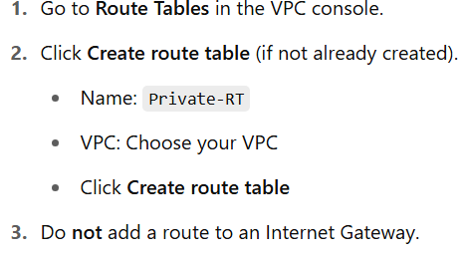

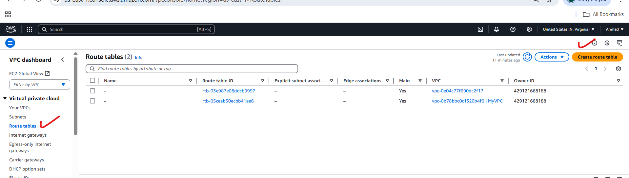

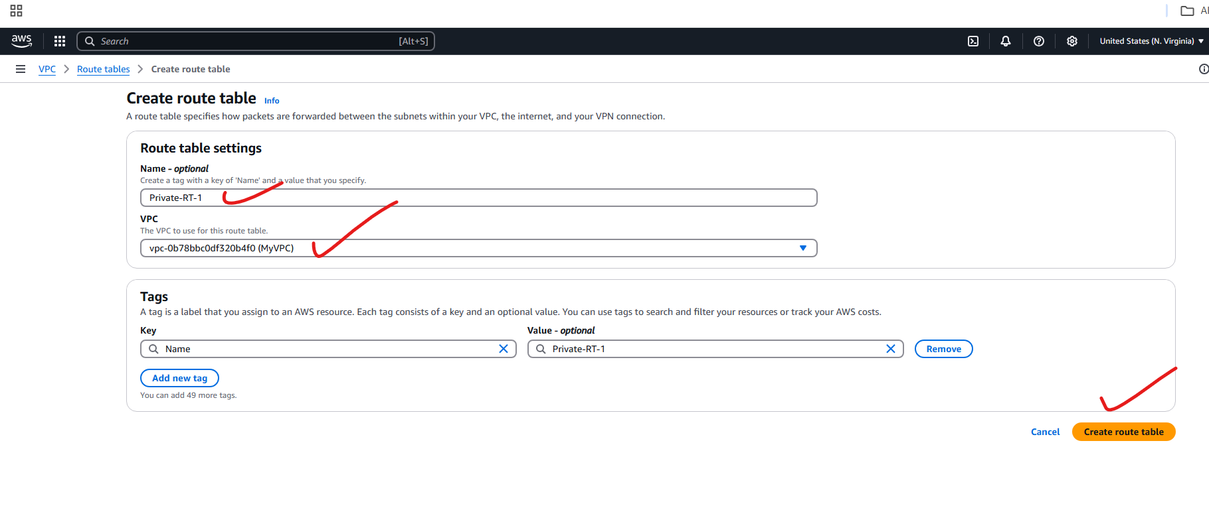

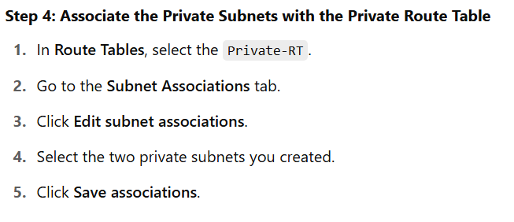

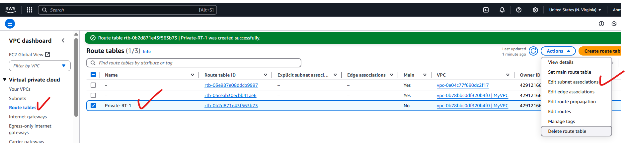

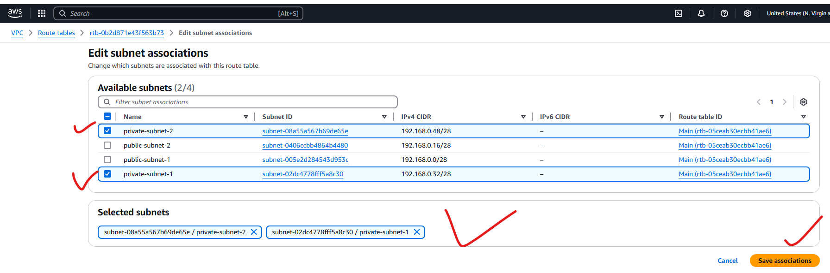

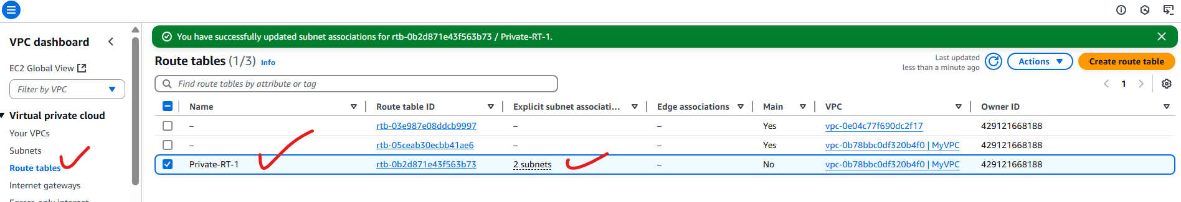

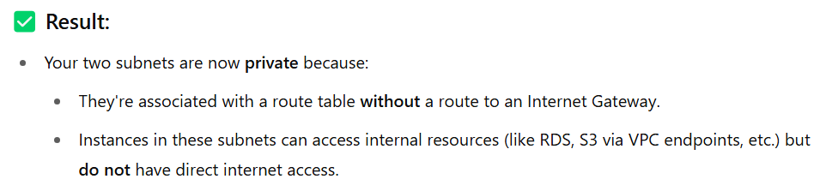

**5) Add 2 public subnets in public route table**

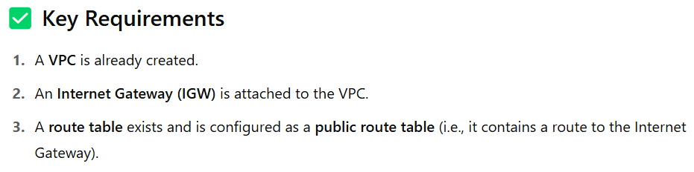

**Create or Identify an Internet Gateway (IGW)**

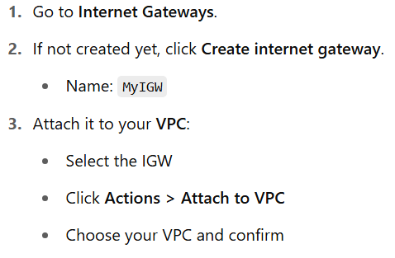

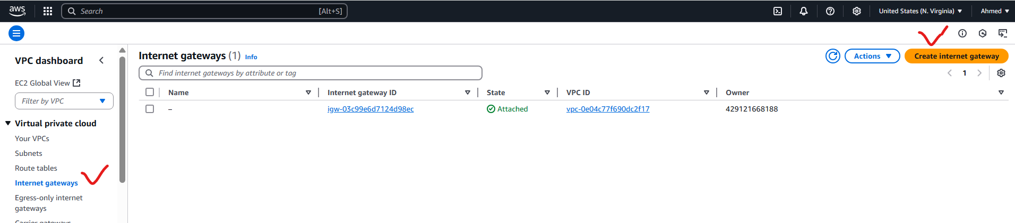

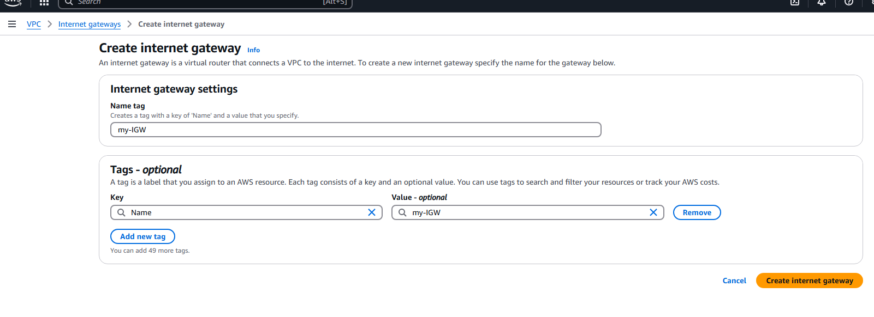

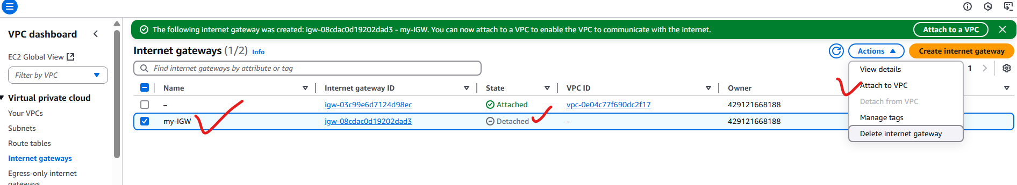

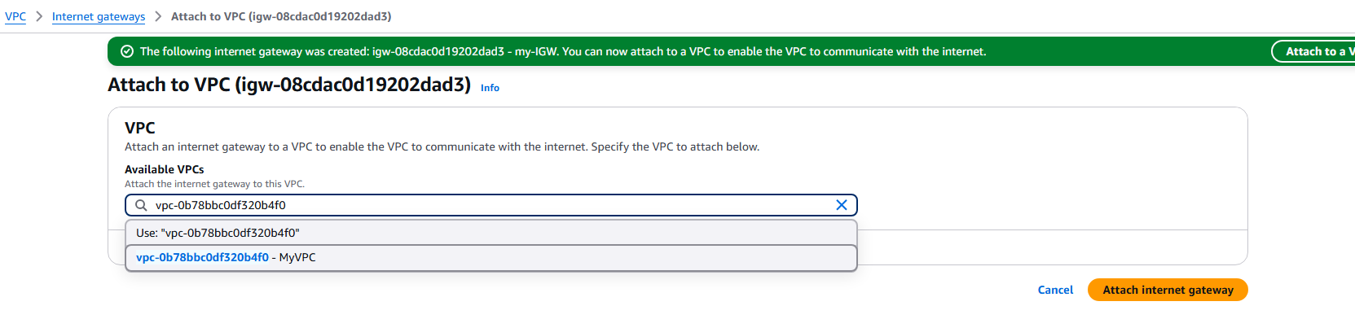

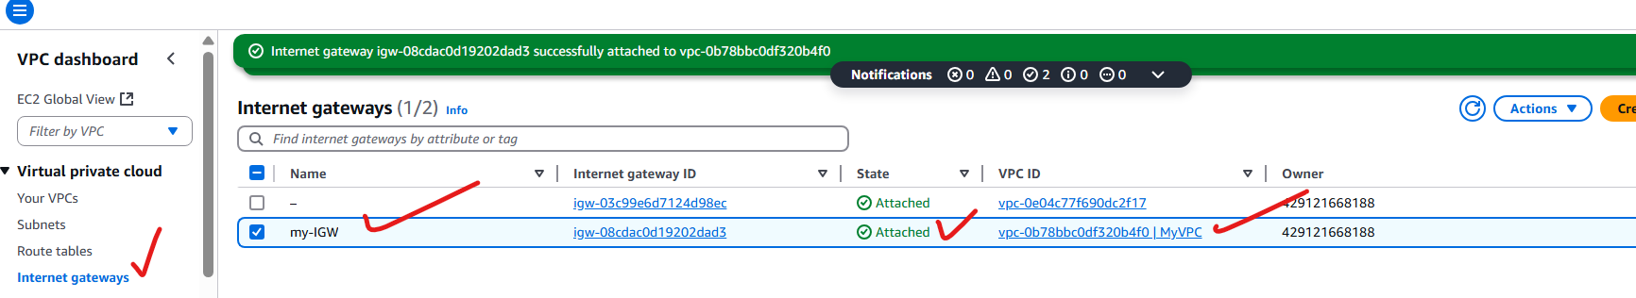

**Create or Identify the Public Route Table**

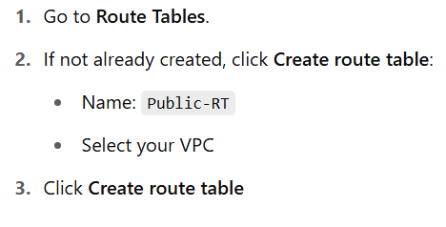

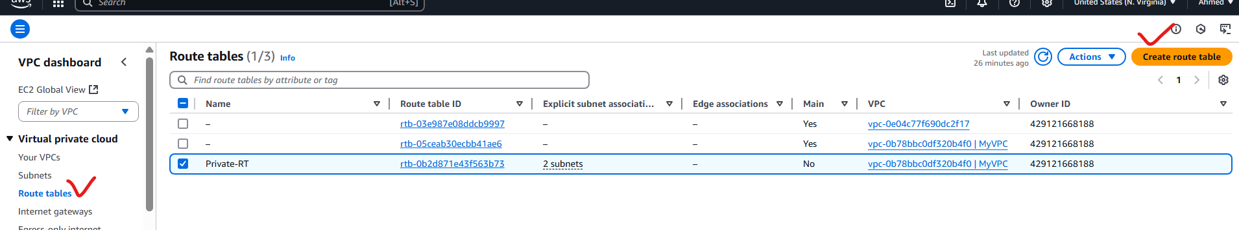

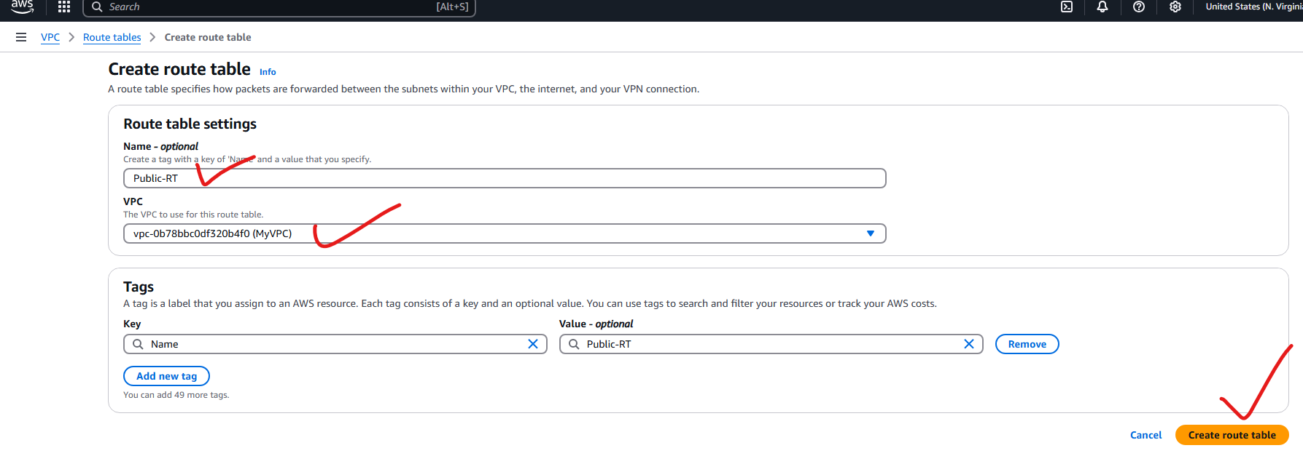

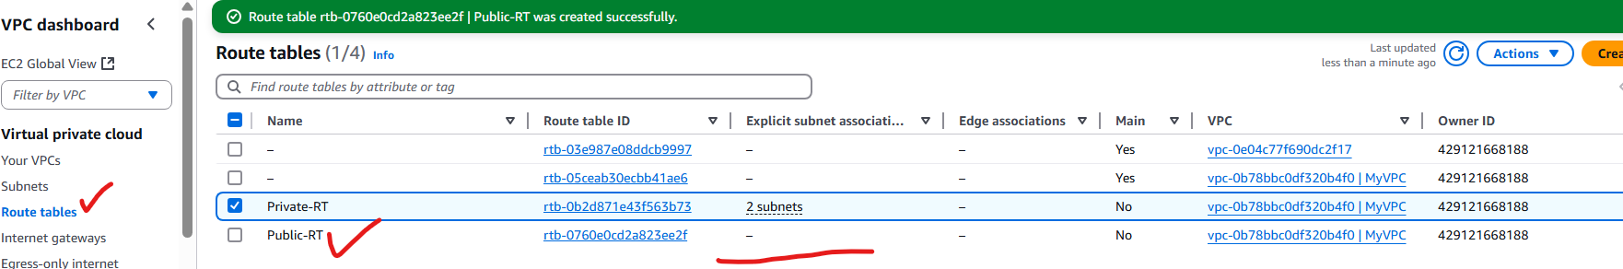

**Add a Route to the Internet Gateway**

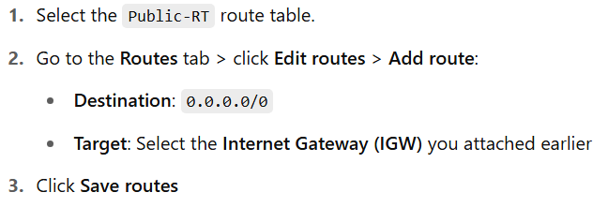

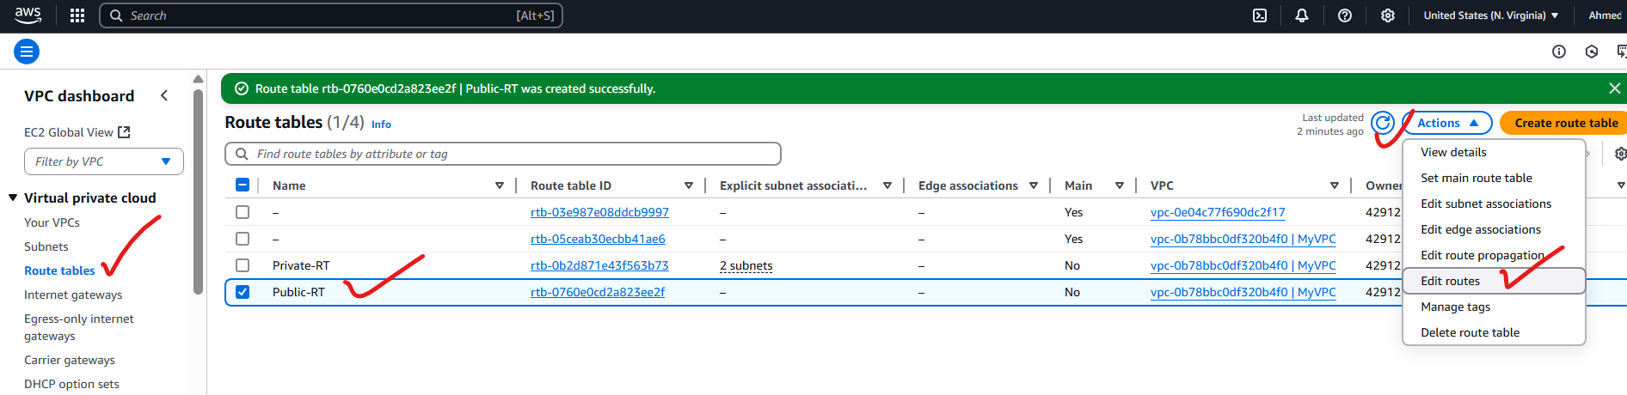

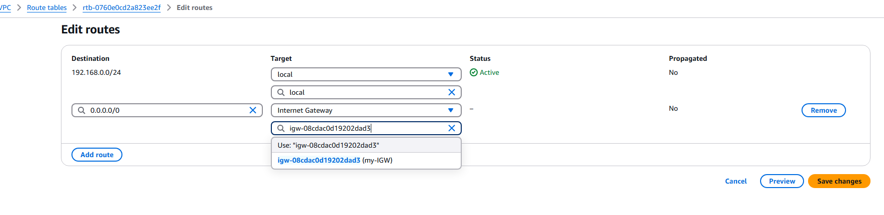



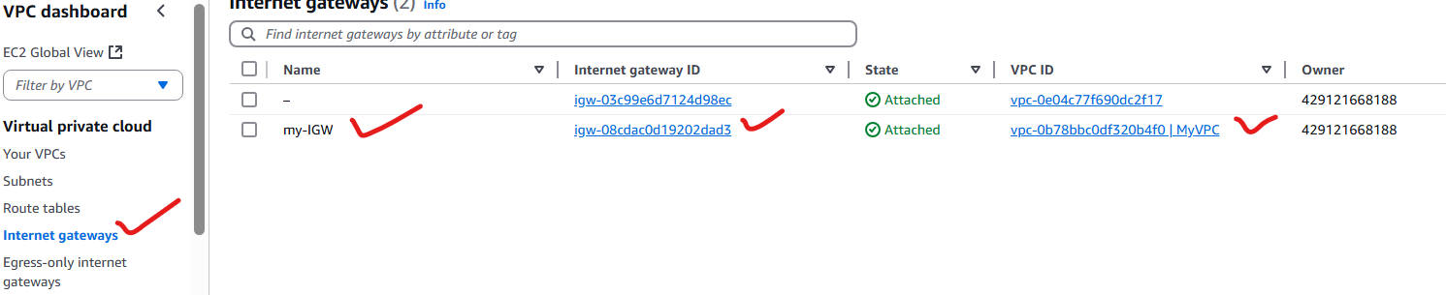

**Associate Public Subnets with Public Route Table**

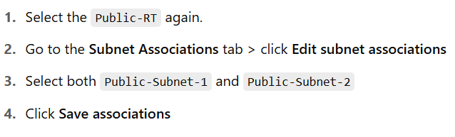

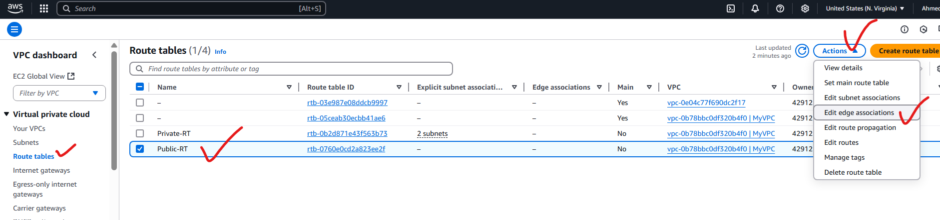

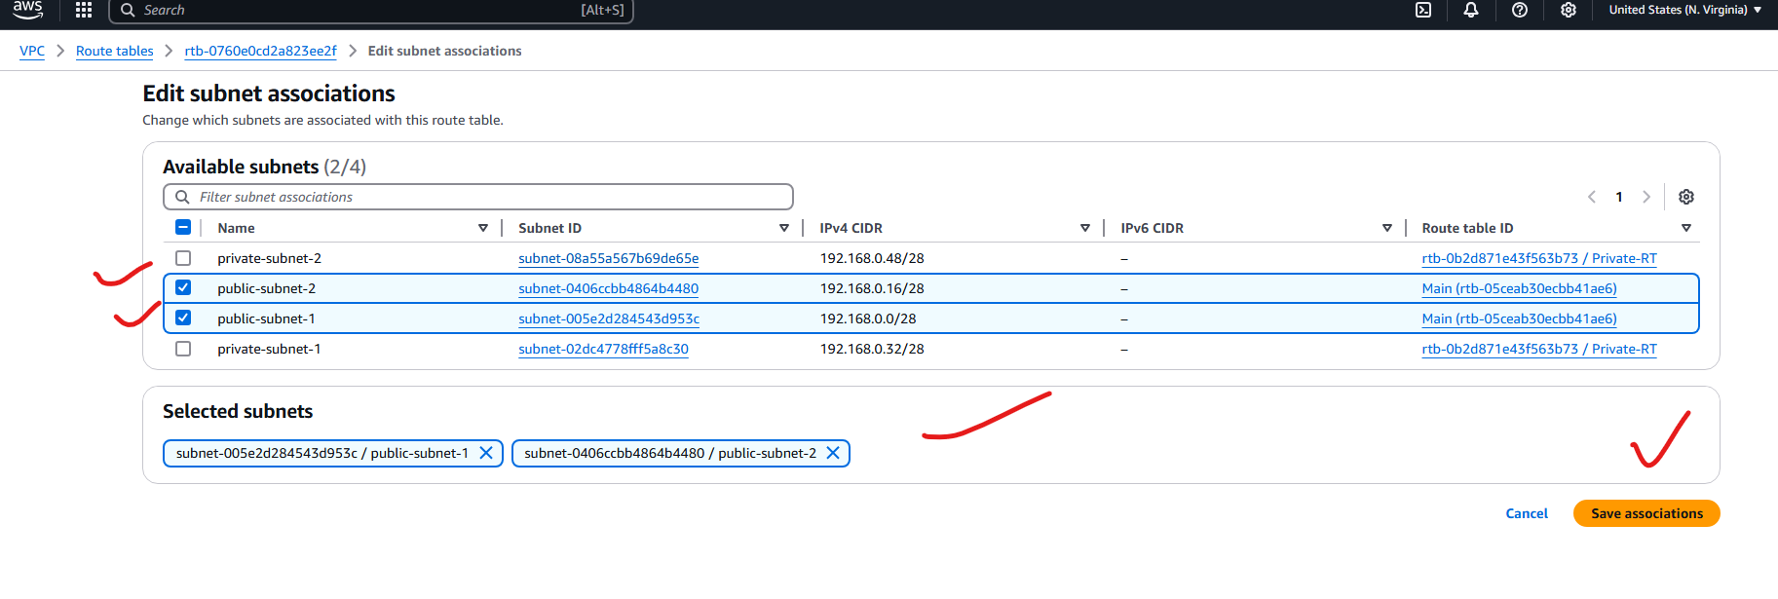

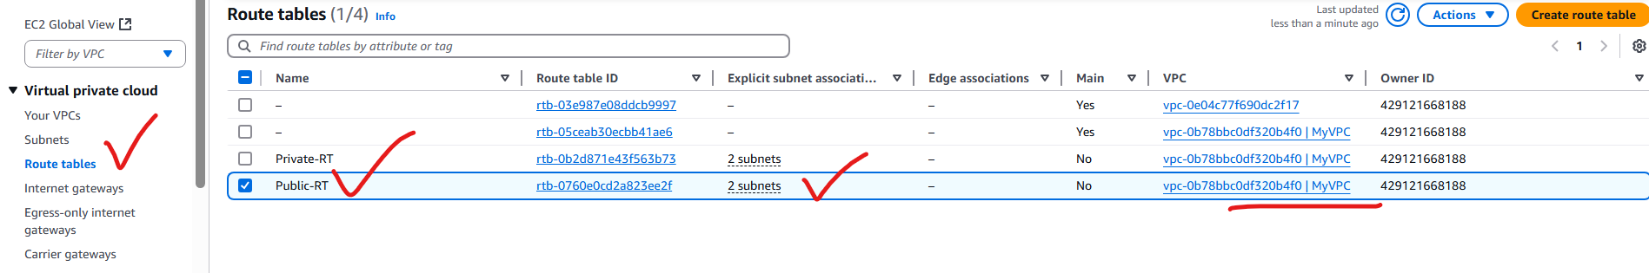

**Enable Auto-assign Public IP (Optional but Recommended)**

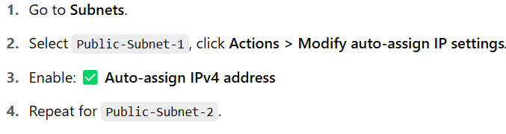

Already Done this step:

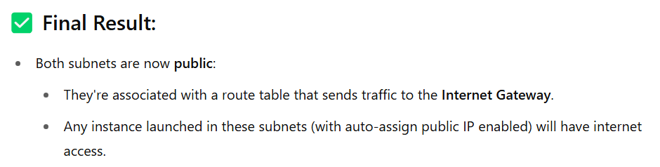

**6) Public route table will have the routes to internet and local**

A public route table in AWS typically has two types of routes:

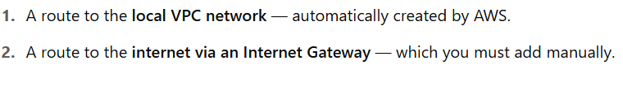



* VPC CIDR block: 192.168.0.0/24
* Internet Gateway: igw-0abc1234567890xyz

**Public Route Table Structure:**

| **Destination** | **Target** | **Description** |
| --- | --- | --- |
| 192.168.0.0/24 | local | Enables communication within VPC |
| 0.0.0.0/0 | igw-0abc1234567890xyz | Enables outbound internet access |

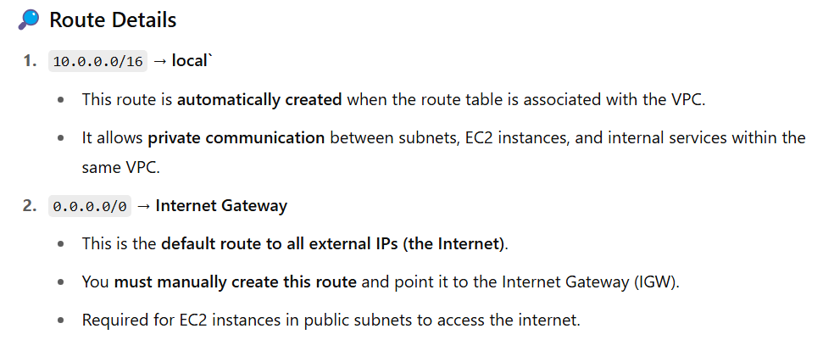

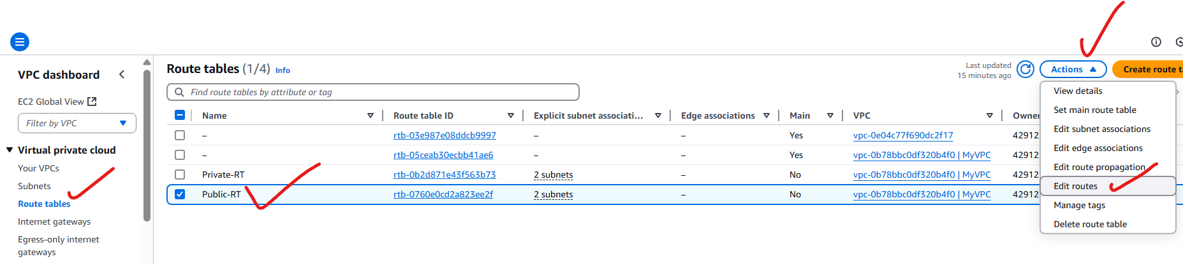

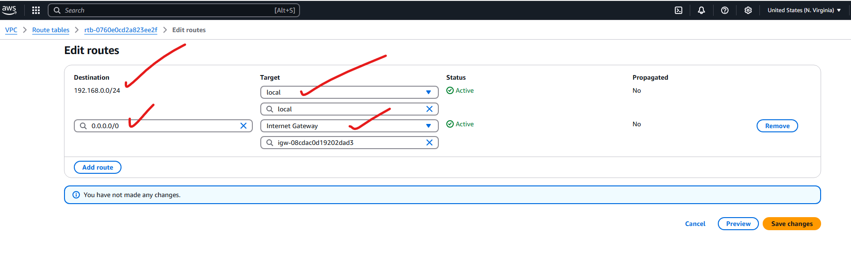

**7) Create Ec2 in public subnet with t2micro and install php**

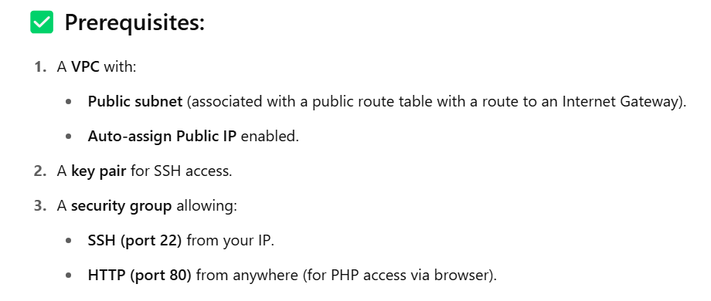

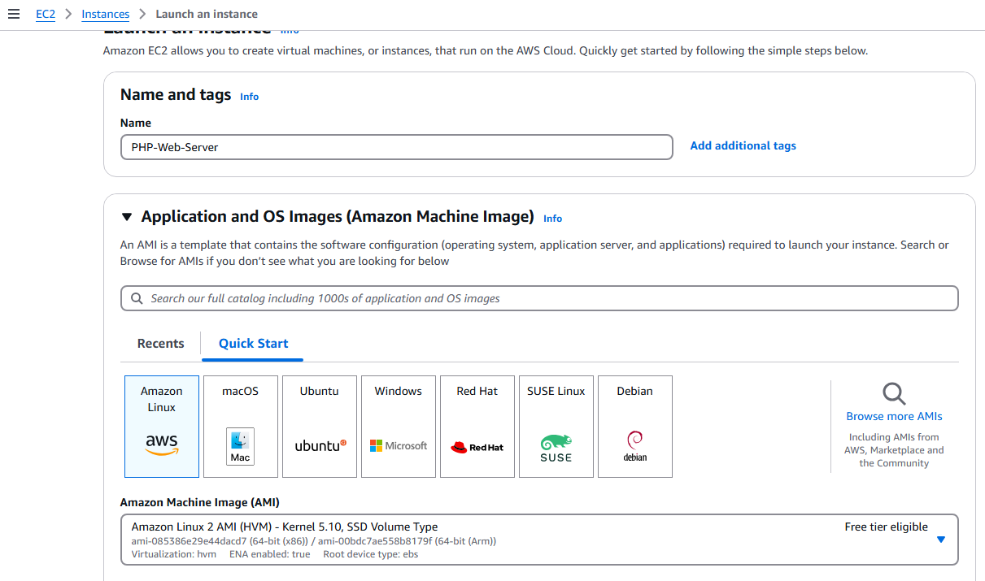

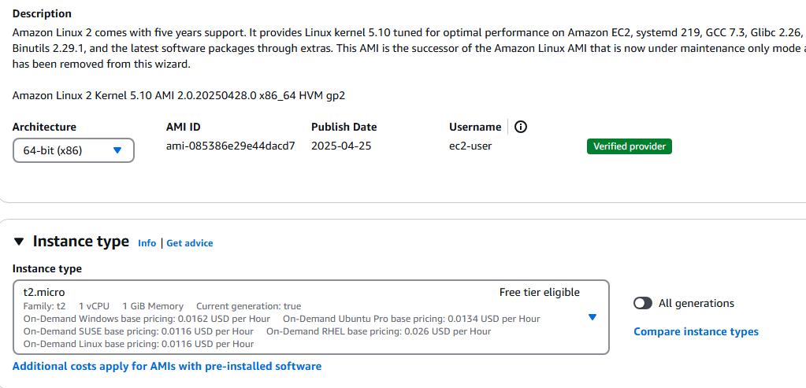

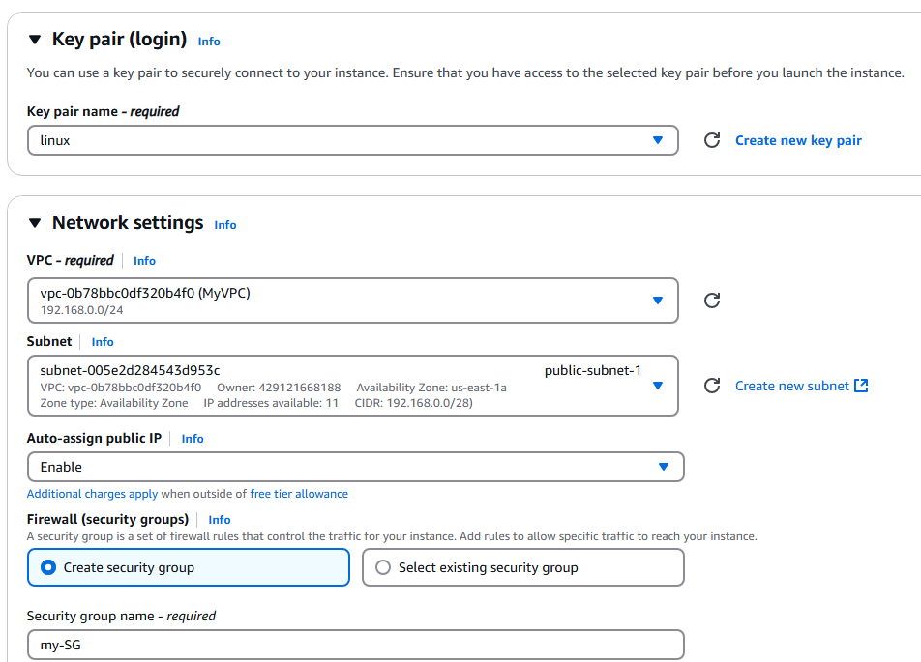

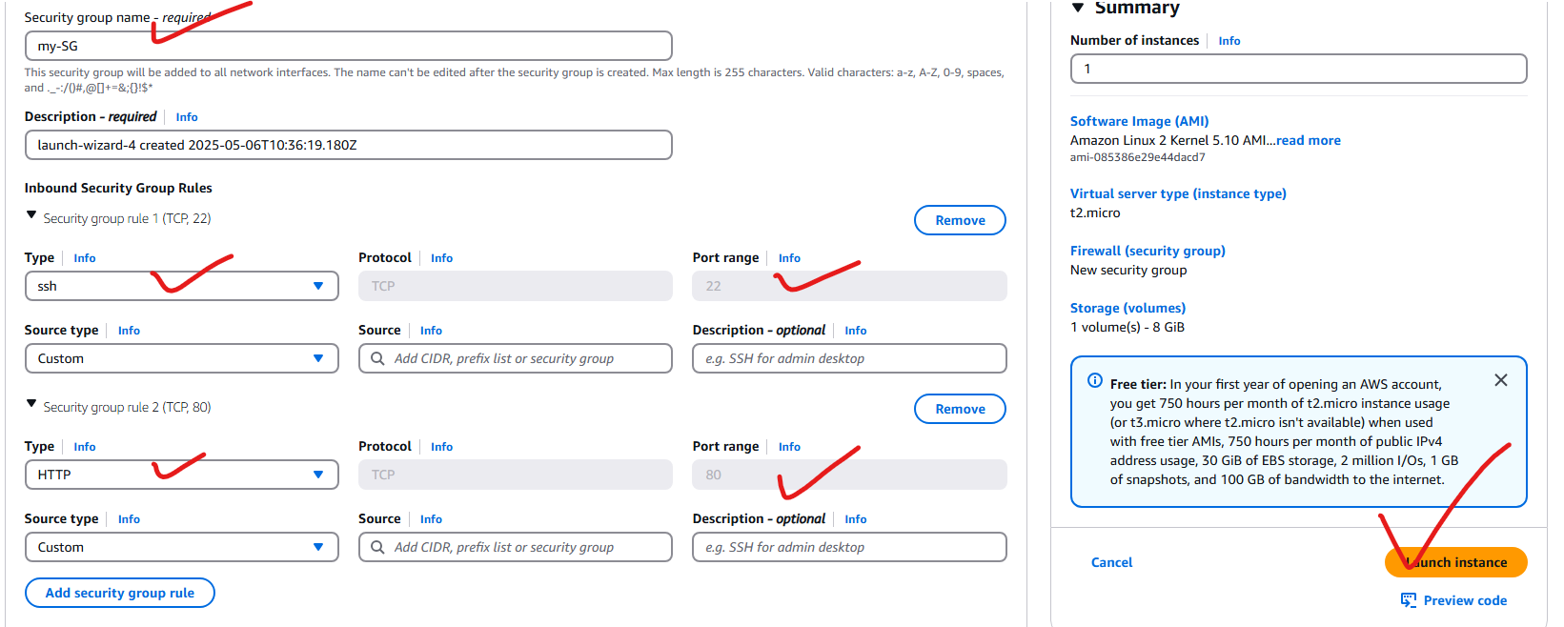

0.0.0.0/0

0.0.0.0/0

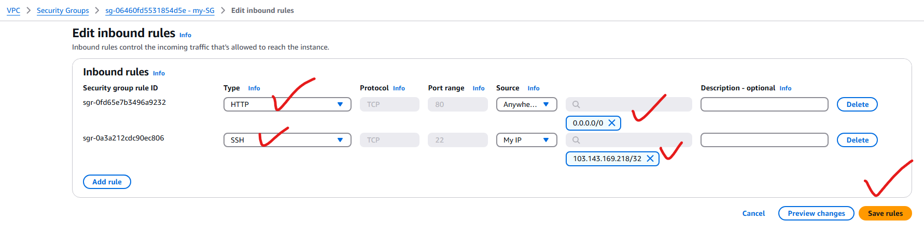



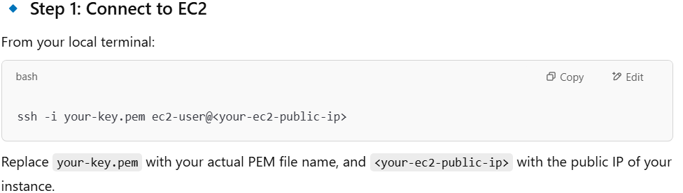

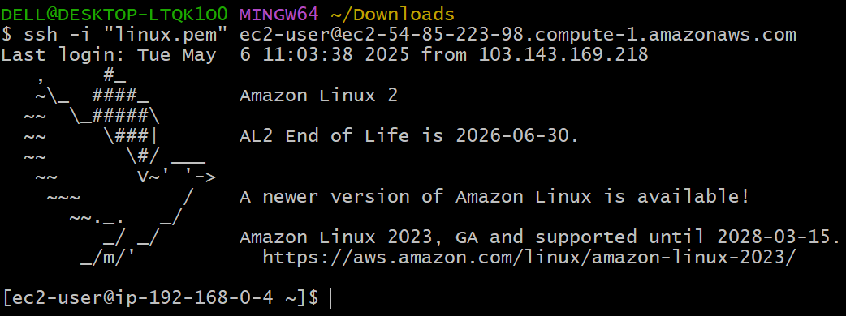

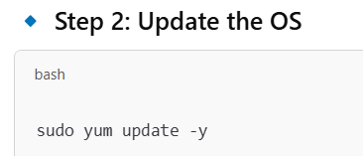

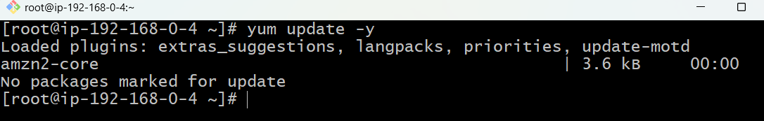

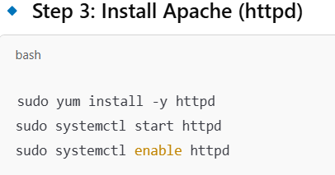

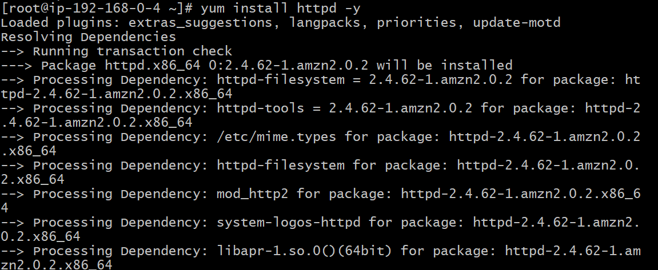

Systemctl status httpd:

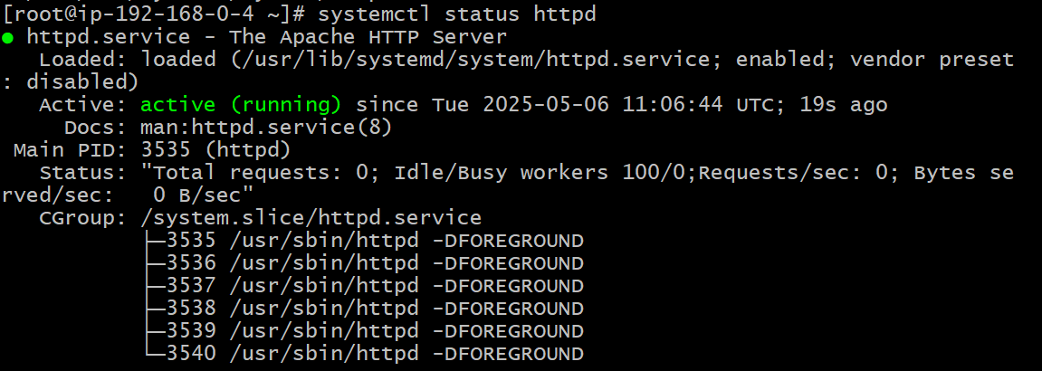

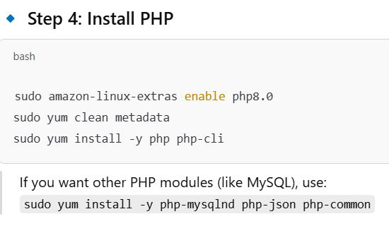

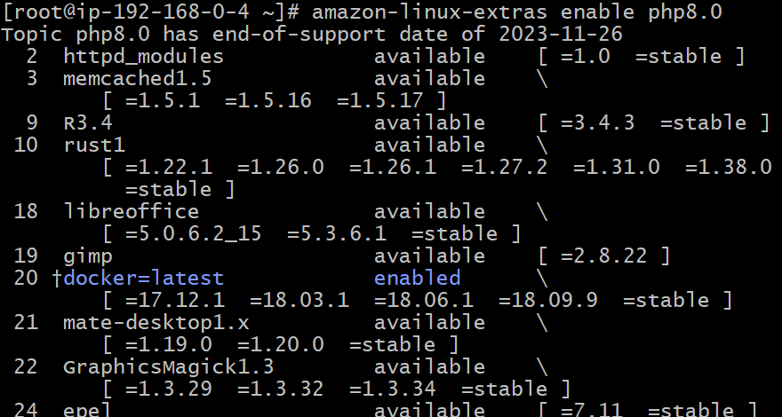

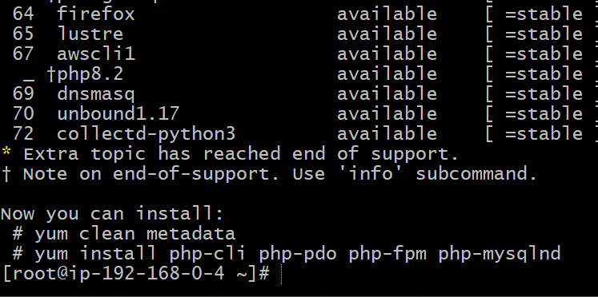

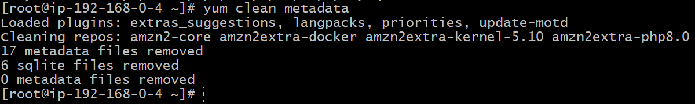

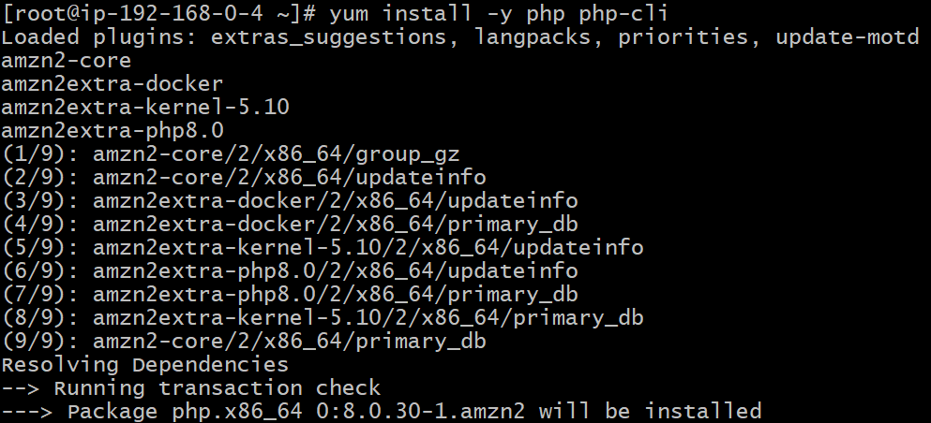

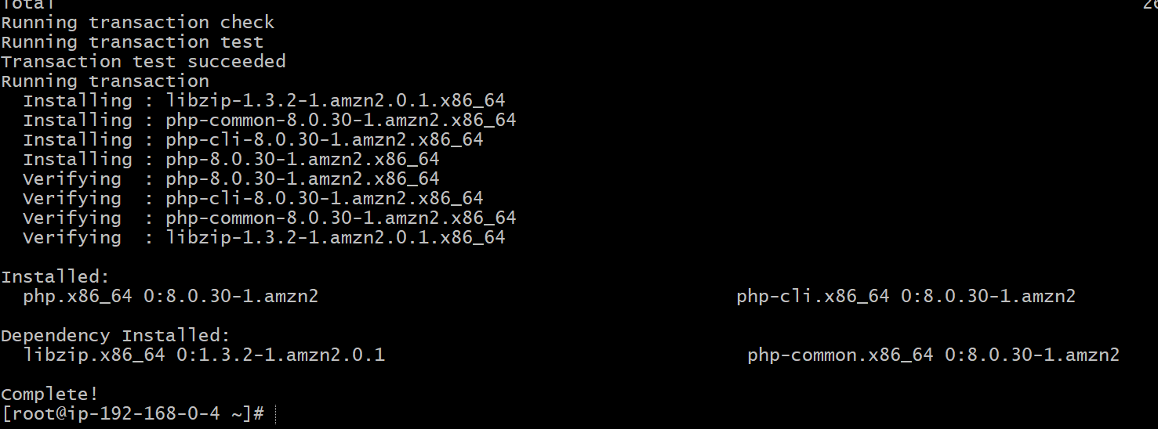

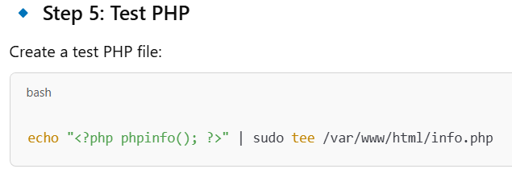



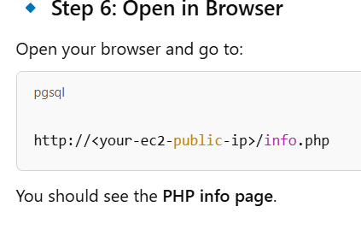

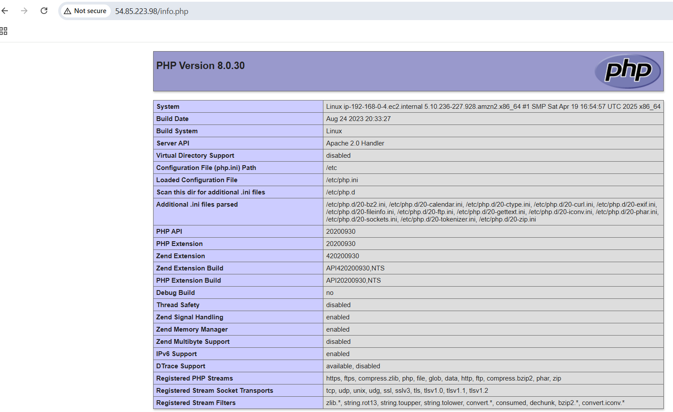

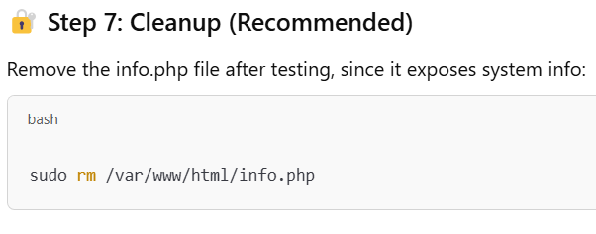

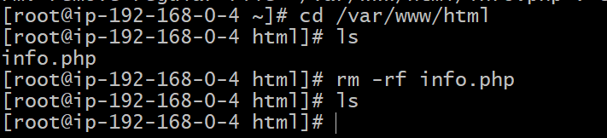

**8) Configure Nat gateway in public subnet and connect to private Instance**

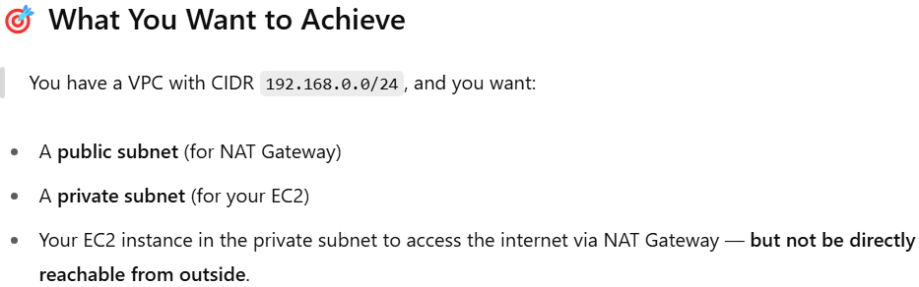

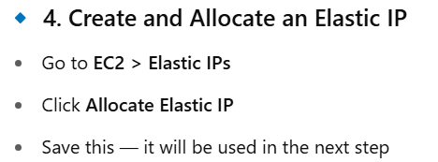

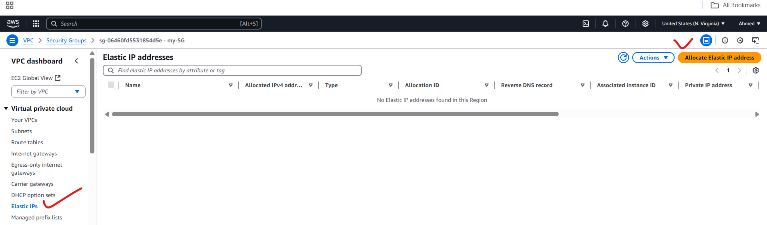

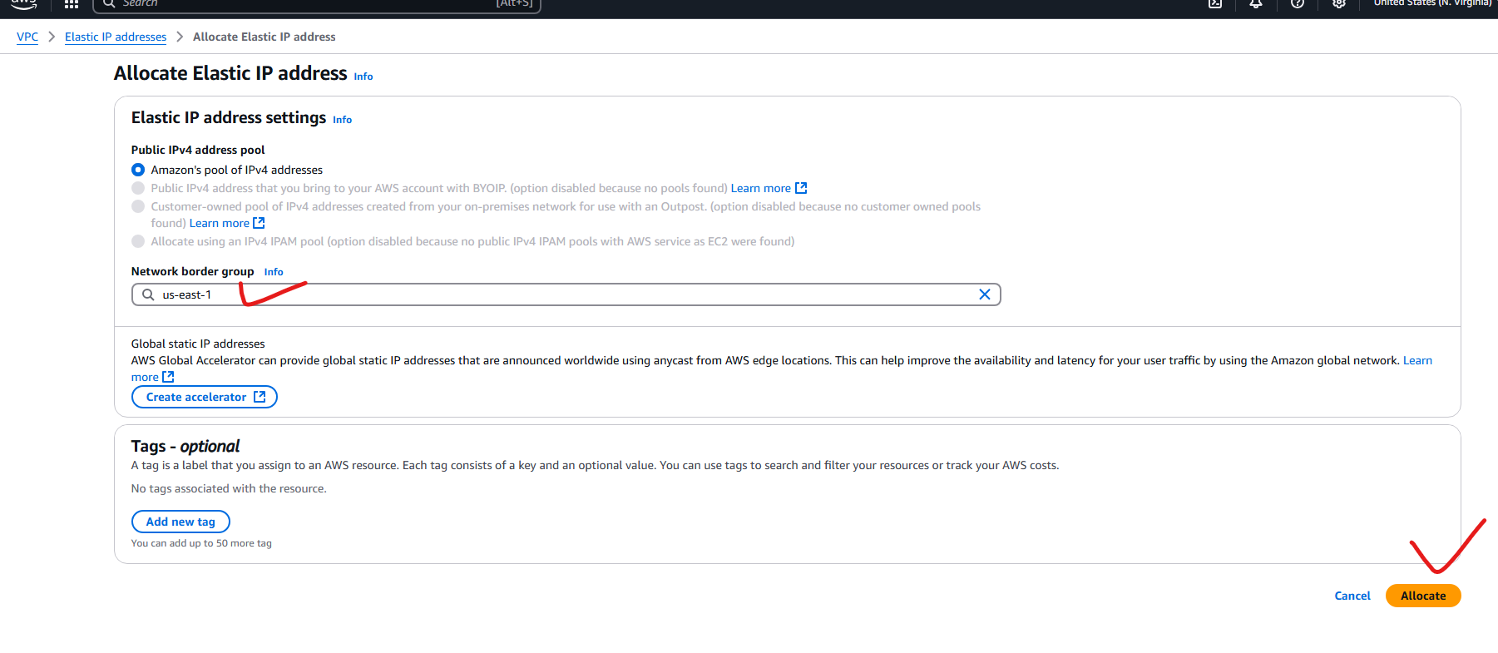

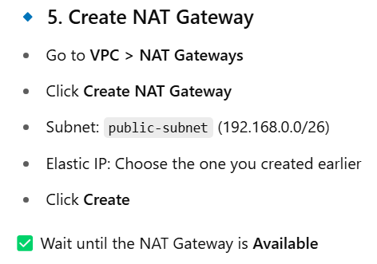

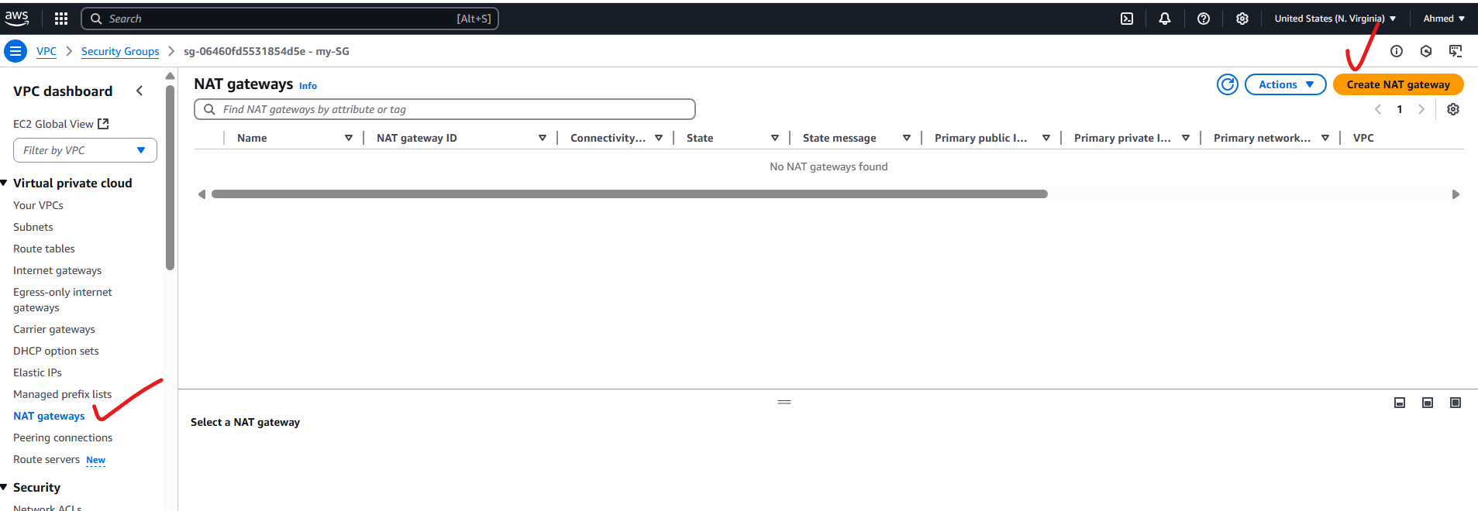

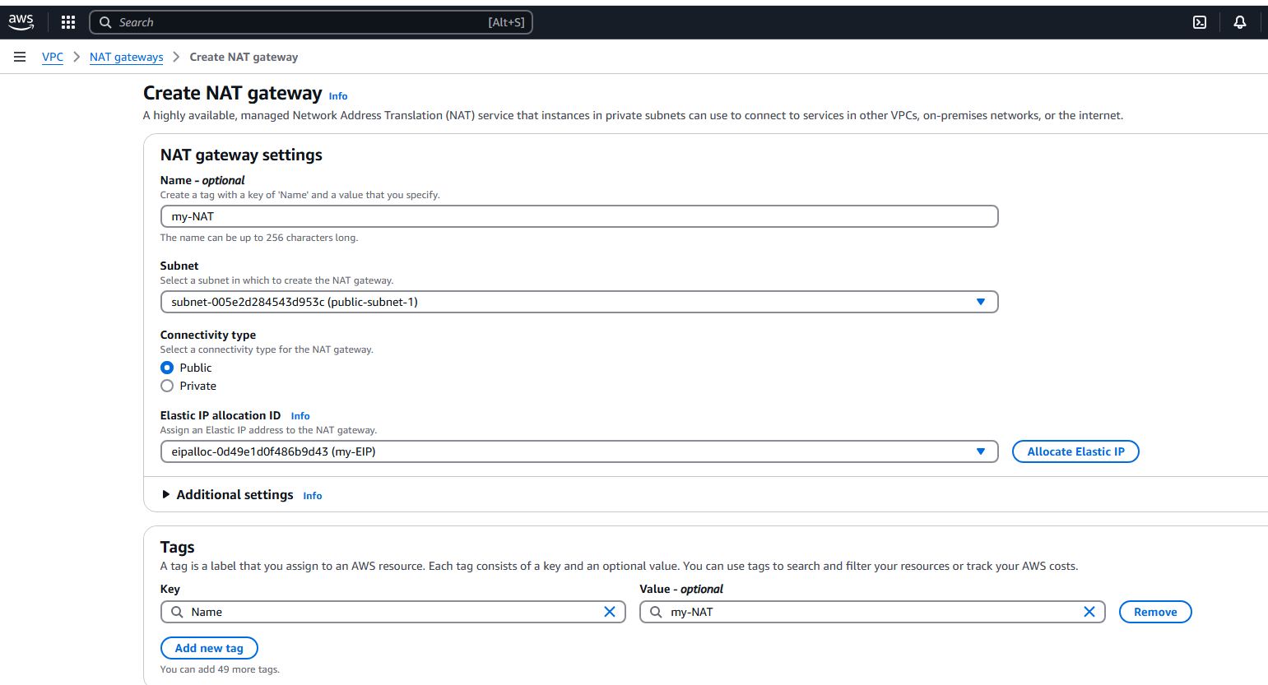

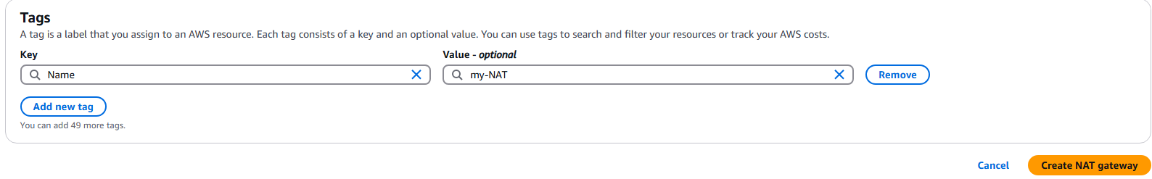

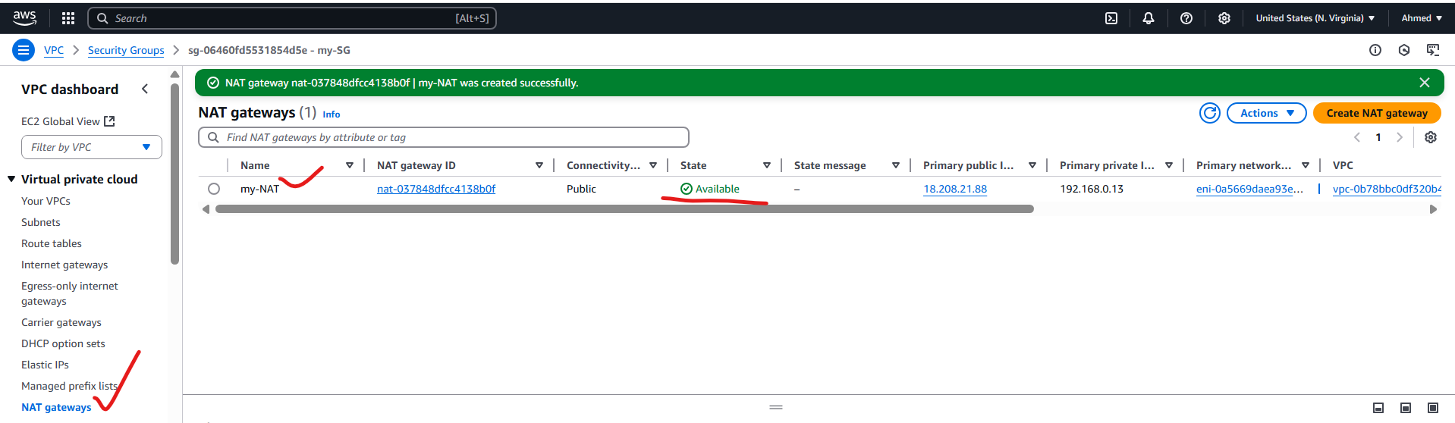

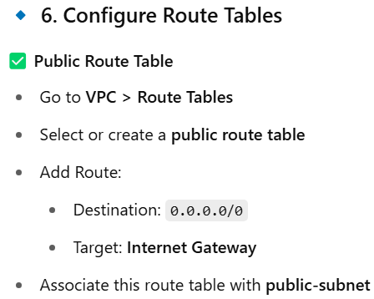

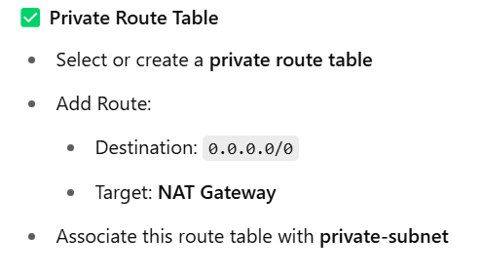

**In Private Route Table:**

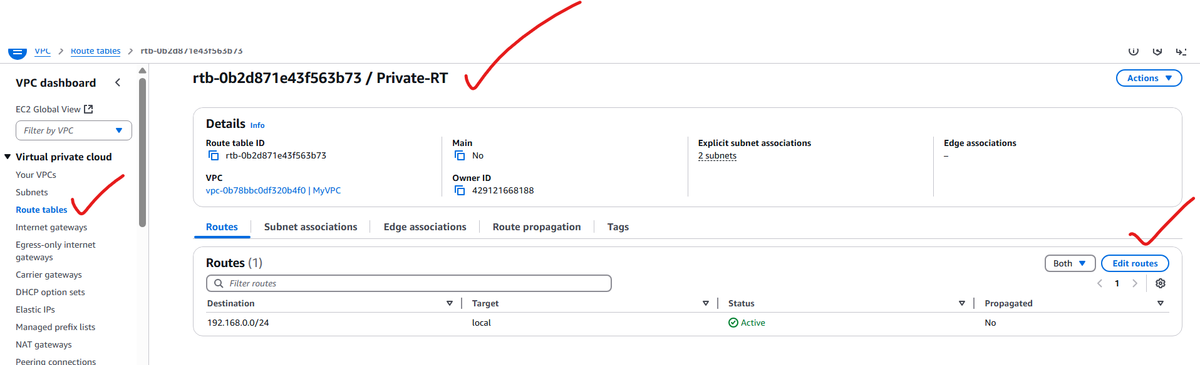

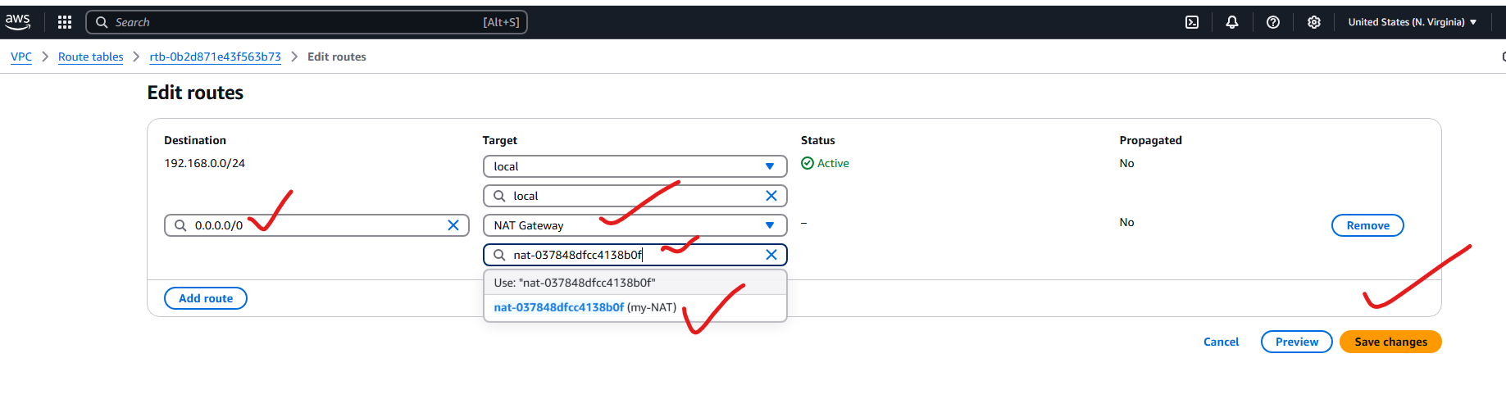

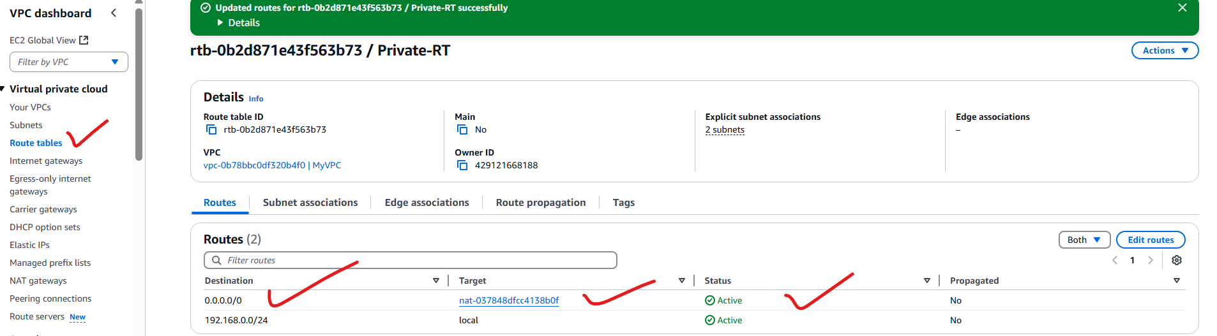

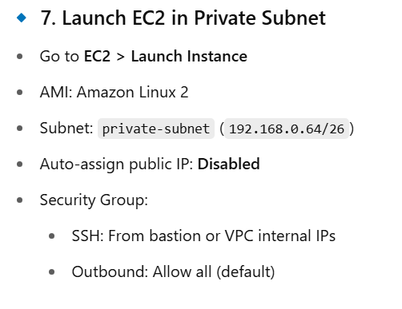

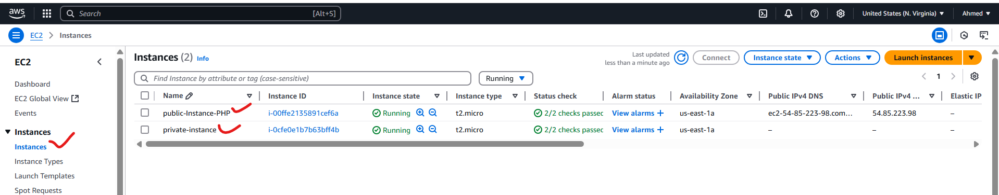

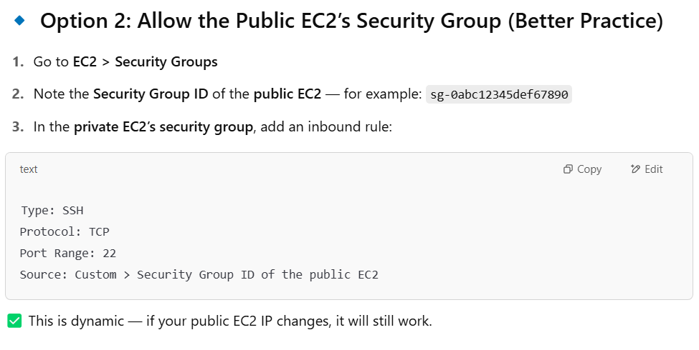

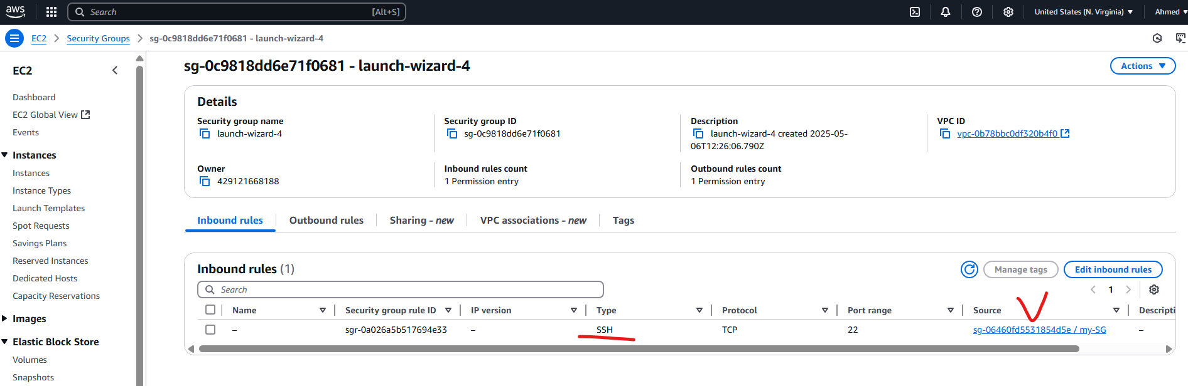

**Public-Instance -Security Group Source:**

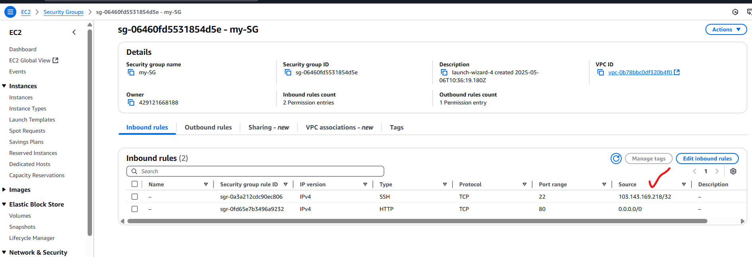

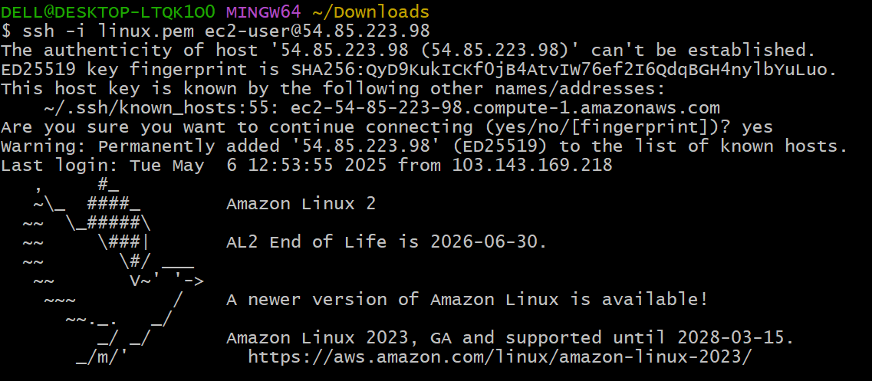

**Copy linux.pem to test.pem and give permissions:**

**chmod 400 test.pem**

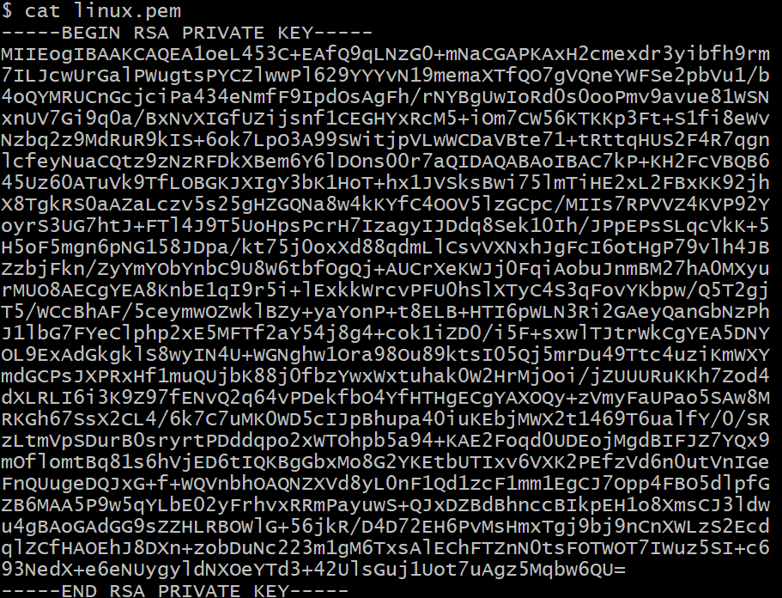

**Connecting public instance to private instance with out IGW:**

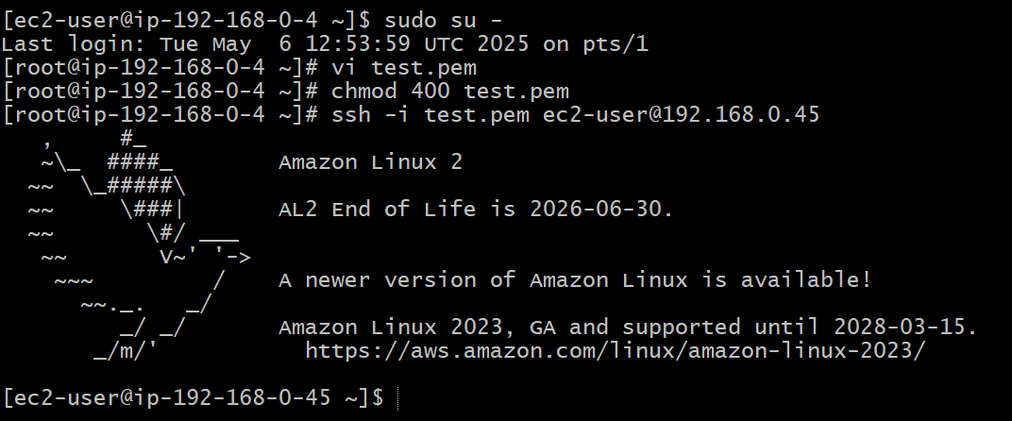

**9) Install Apache Tomcat in private ec2 and deploy a sample app.**



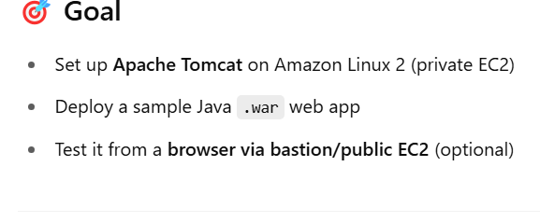

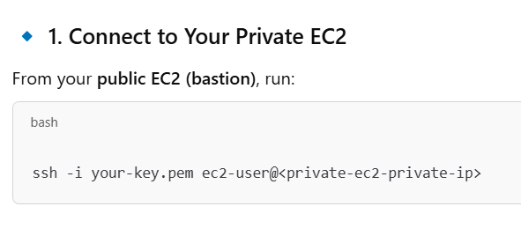

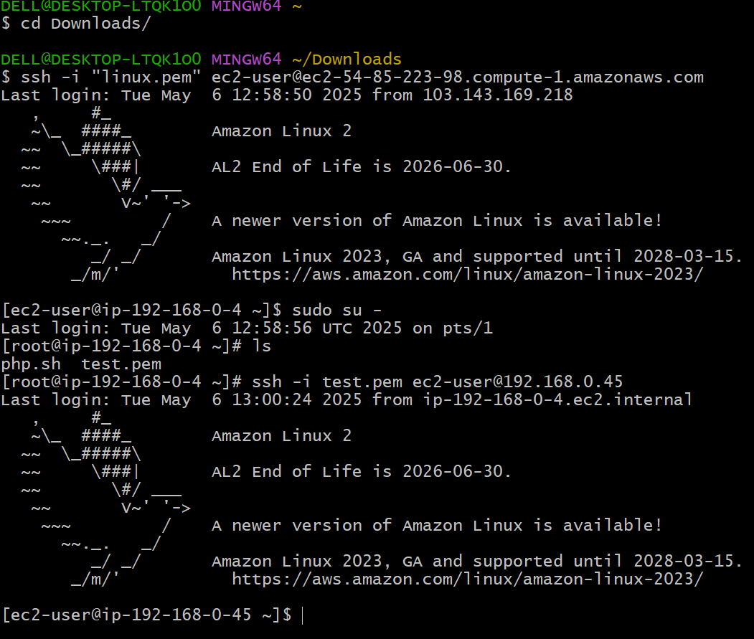

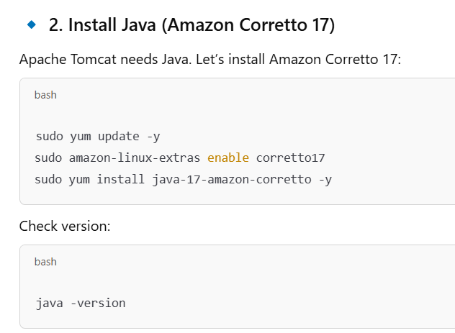

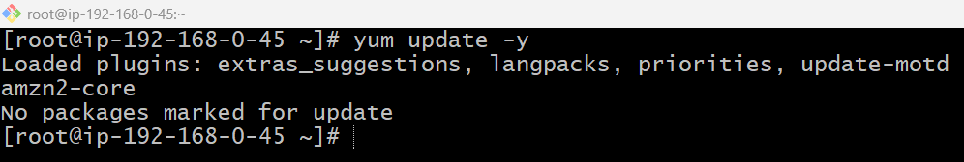

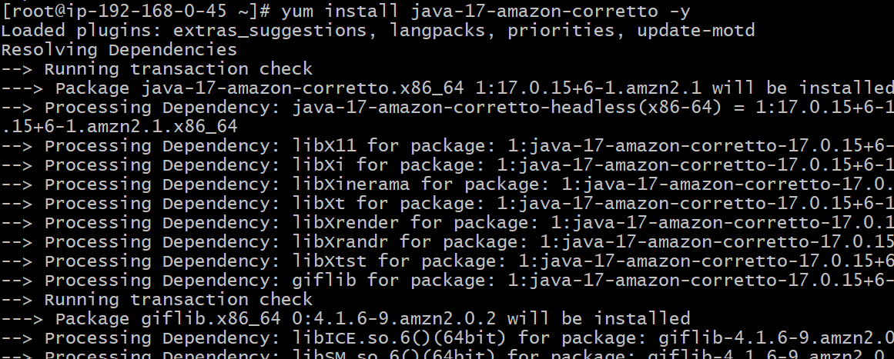

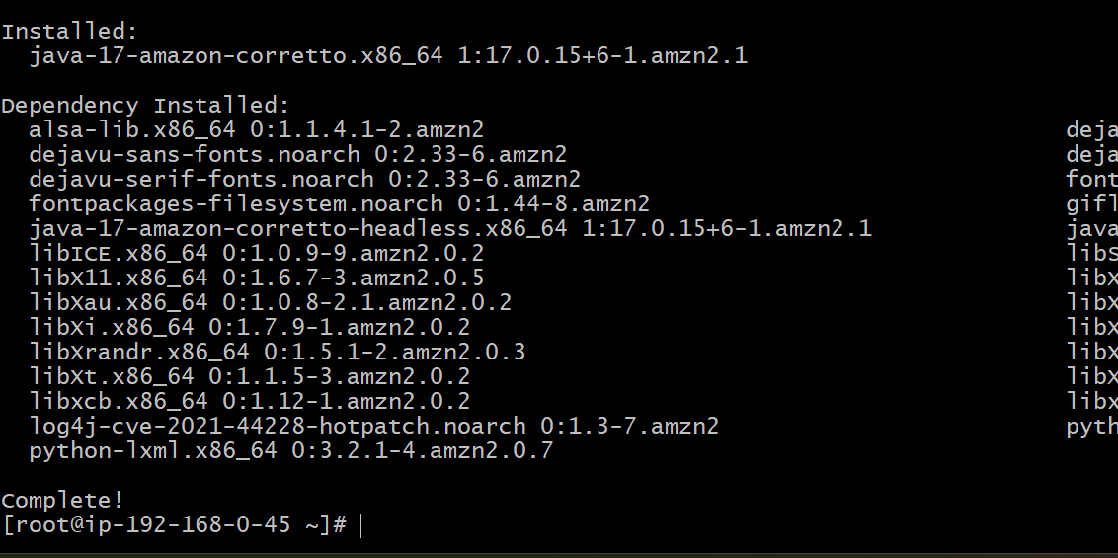

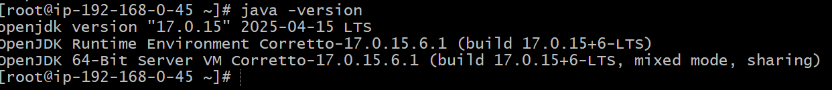

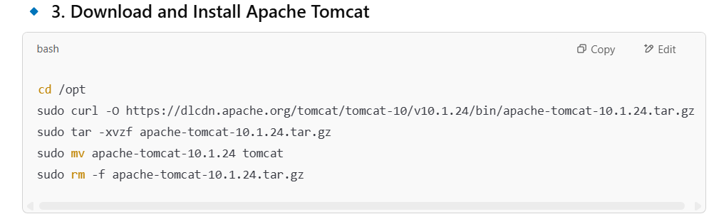

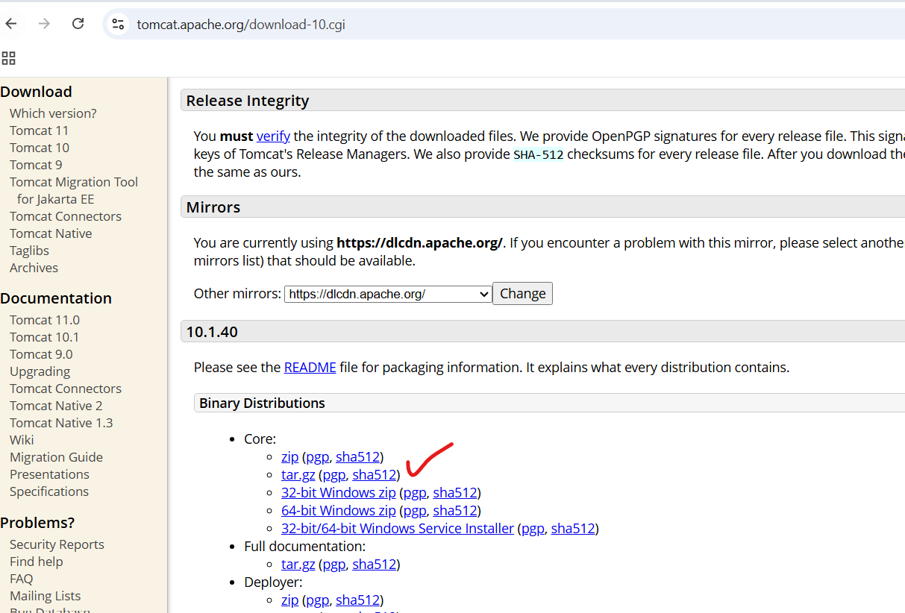

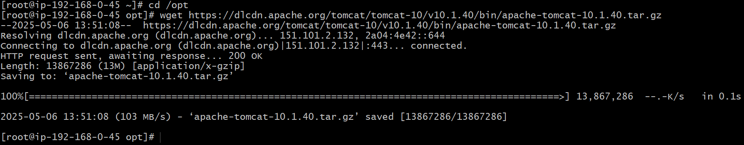

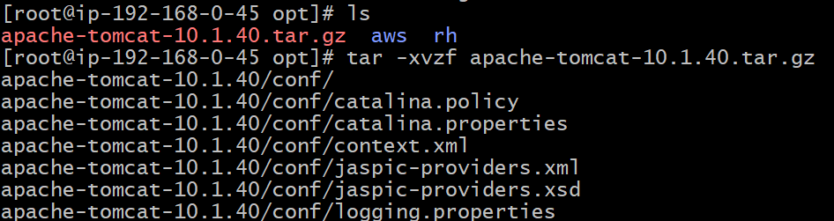

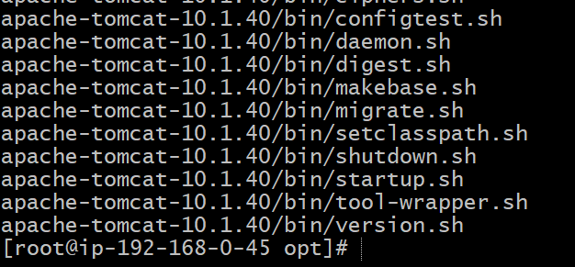

**Moving extracted file to tomcat:**

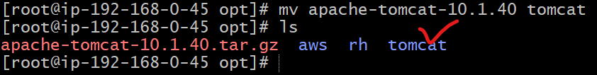

**Removing .tar.gz file also:**

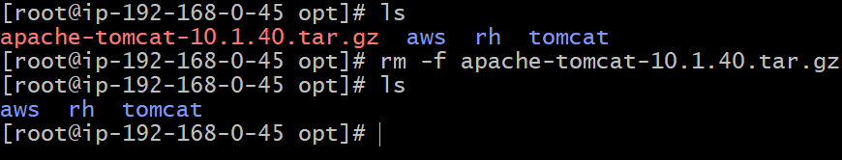

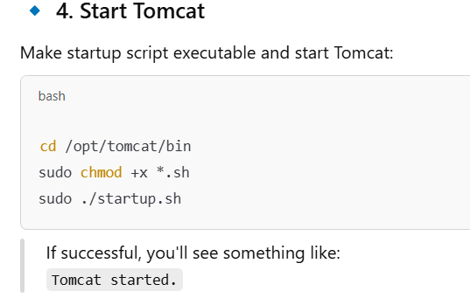

**Changing directory to bin:**

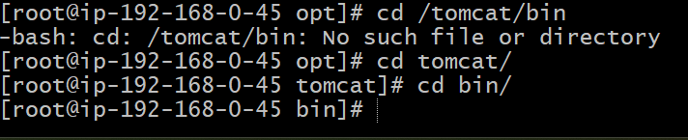

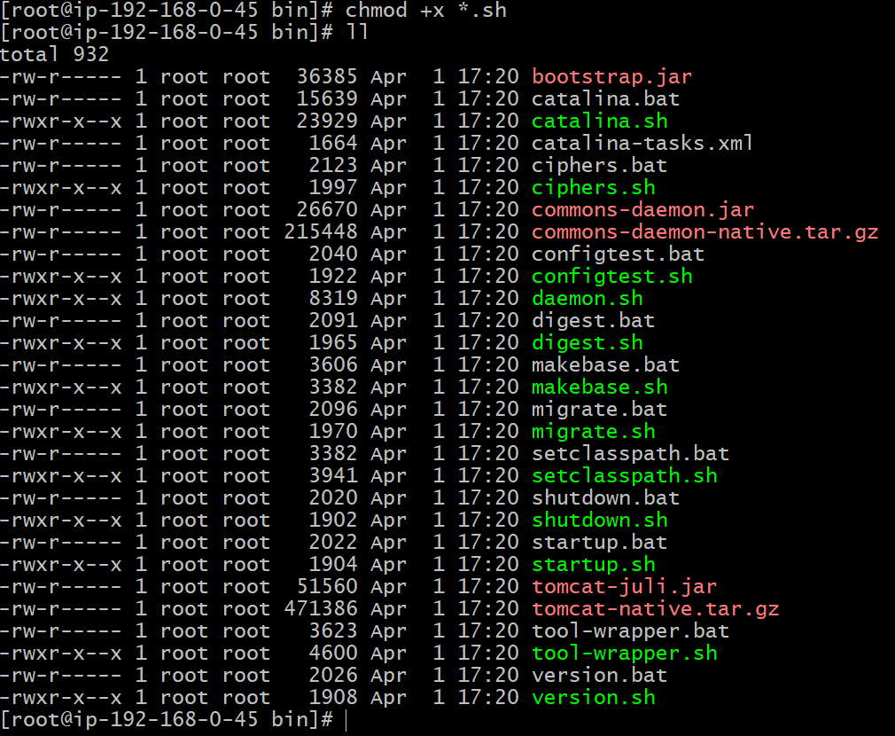

**Tomcat Started:**

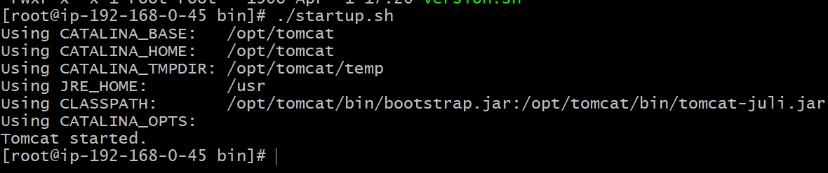

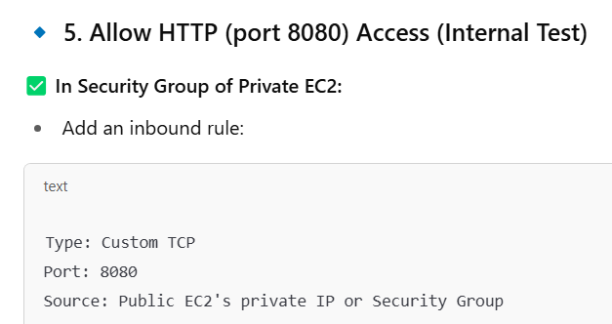

**Private Instance – security group-inbound rules:**

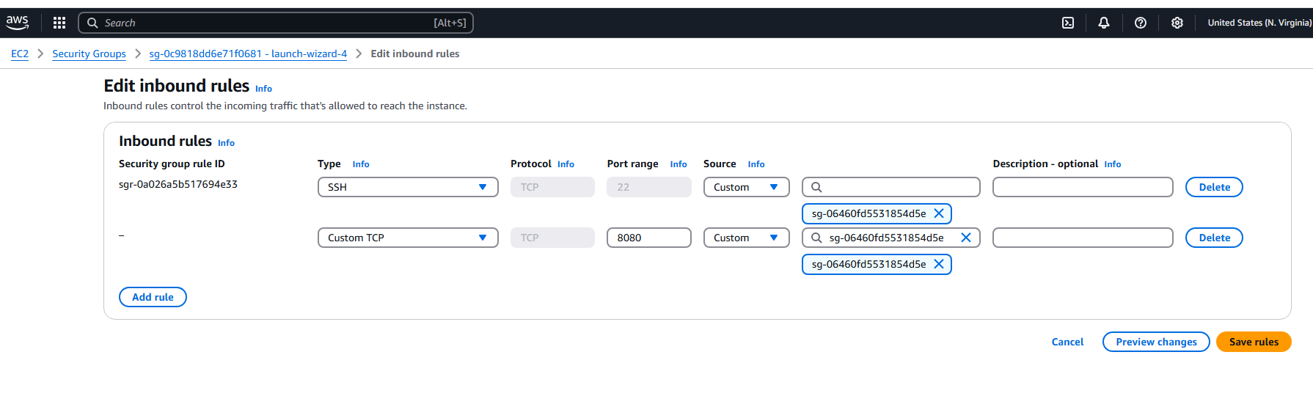

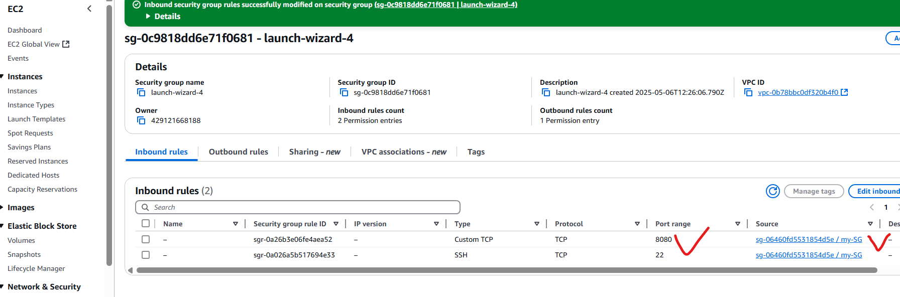

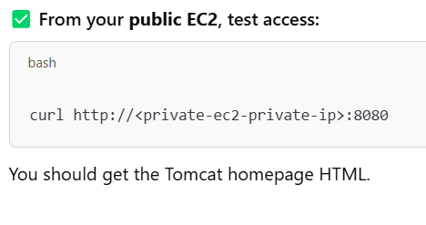

**Getting output: successfully**

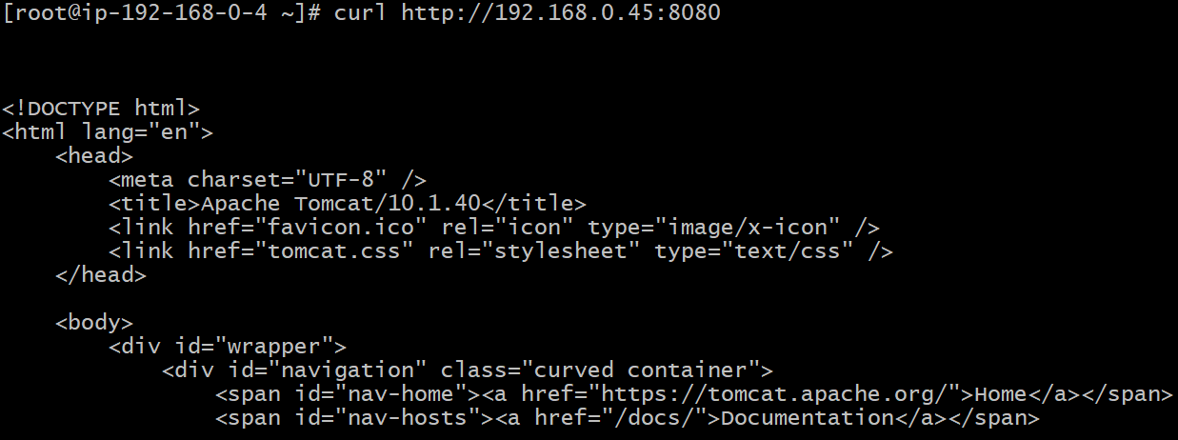

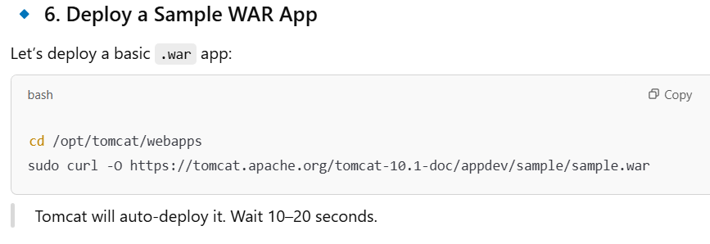

**Go to private instance and download sample.war file from internet:**

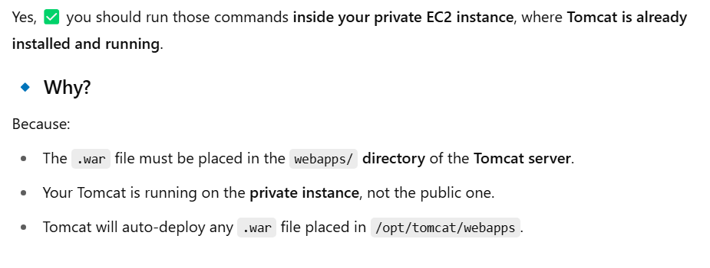

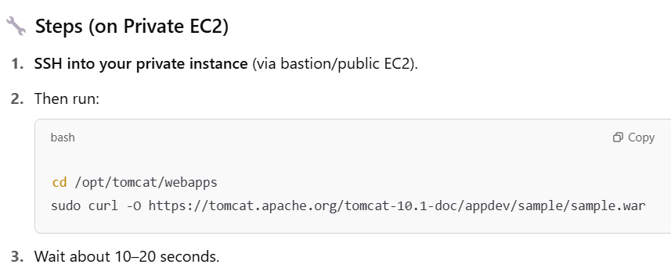

**Connected to private instance with public instance:**

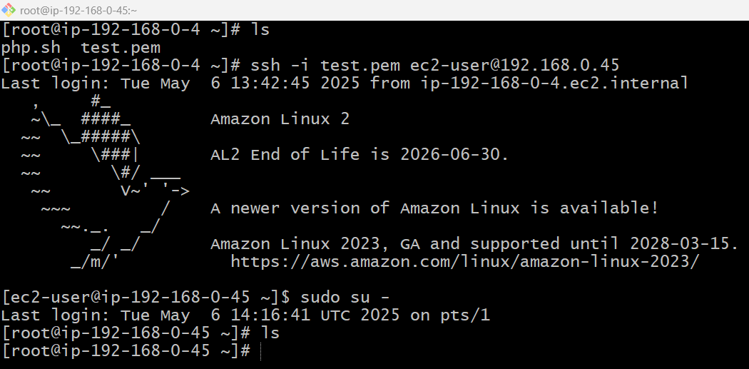

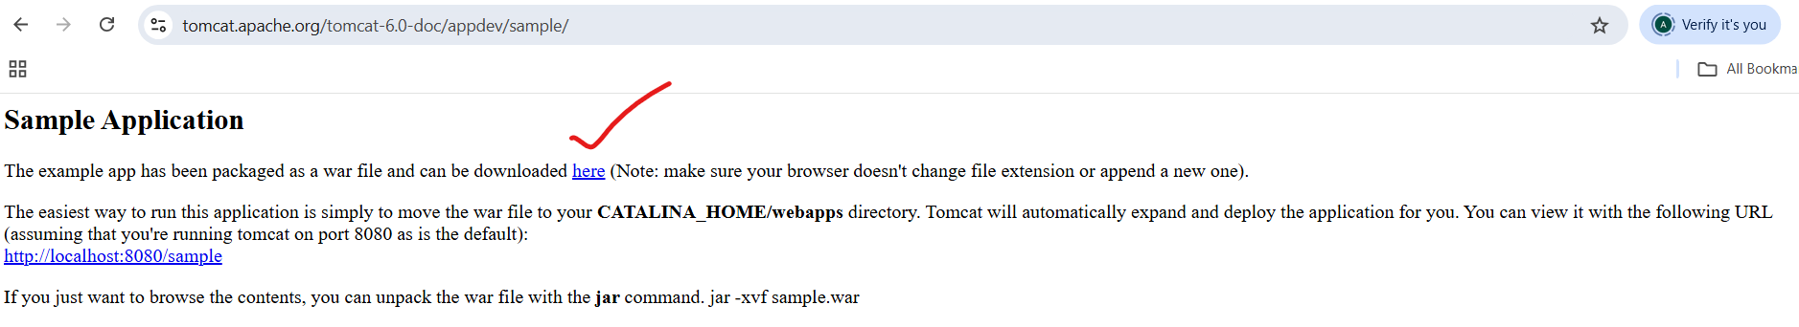

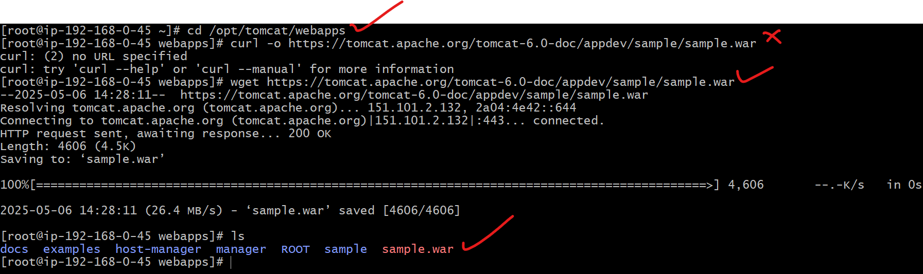

**Tomcat got installed in private instance:**

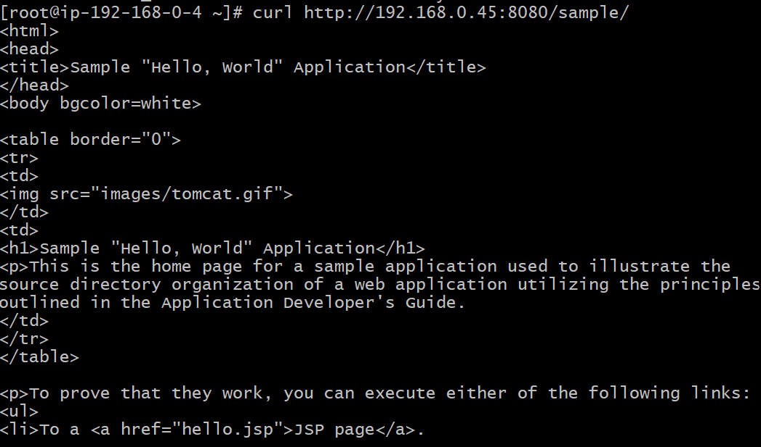

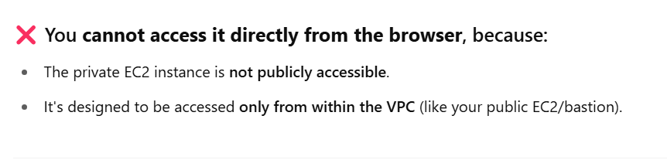

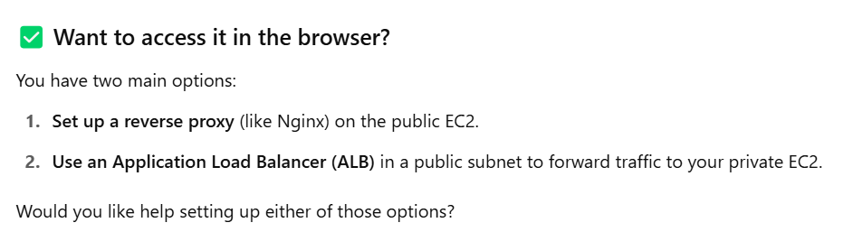

**10) Configure VPC flow logs and store the logs in s3 and cloudwatch.**

Here's a step-by-step guide to configure VPC Flow Logs and store them in both Amazon S3 and CloudWatch Logs.

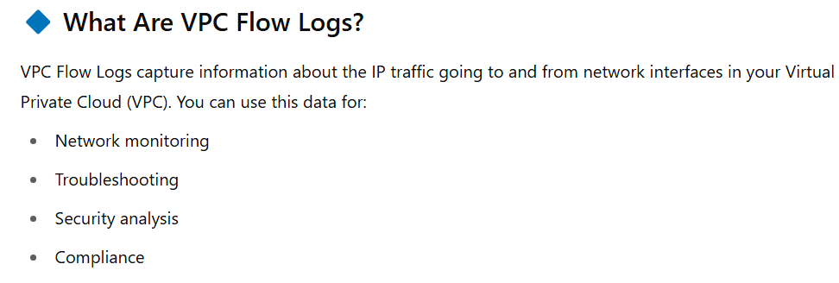

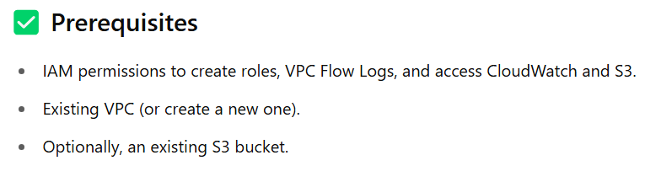

**Creating VPC Flow Logs on CloudWatch:**

**Step1:**

* **We need vpc configured: (taken default vpc)**
* **Launched one ec2 instance with public subnet**
* **Installed httpd on that instance**

**Step:2**

* **Got to IAM service from AWS**

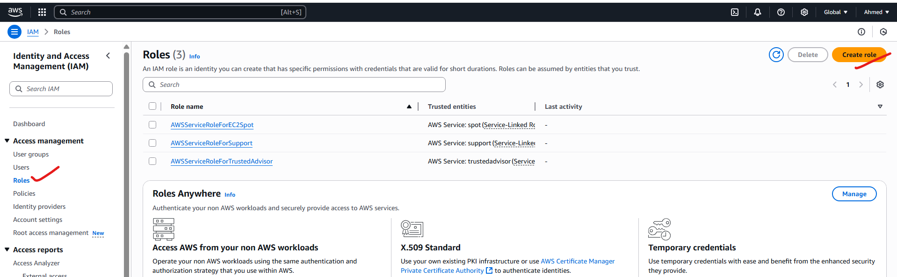

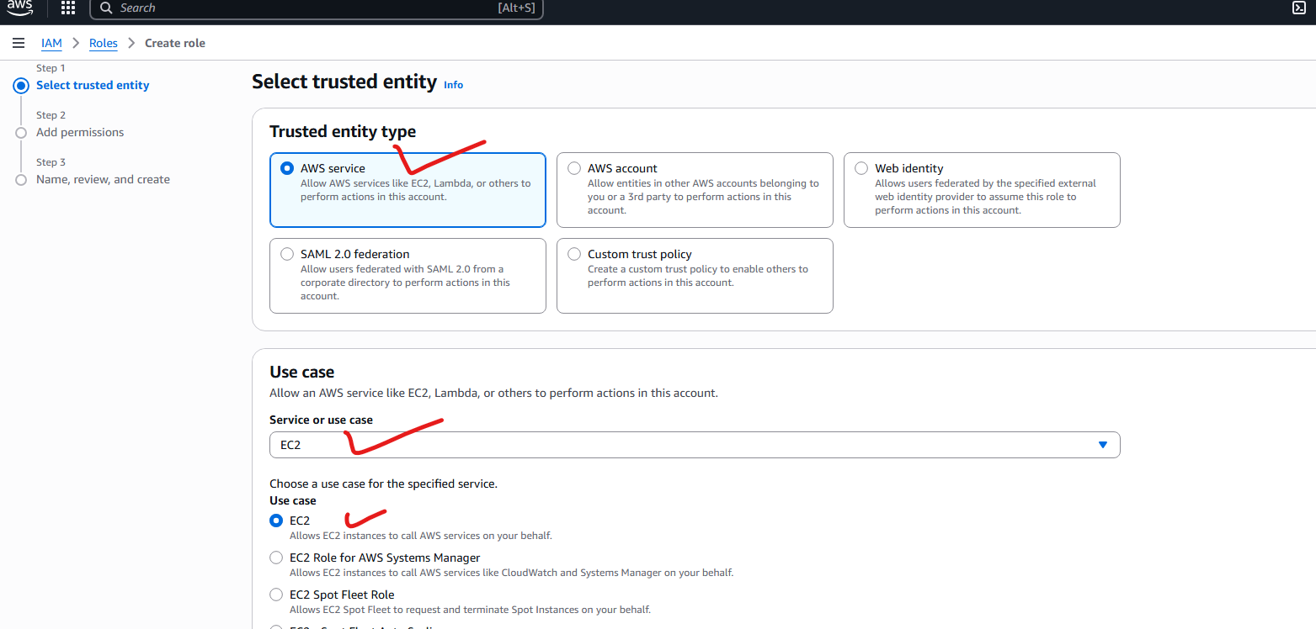

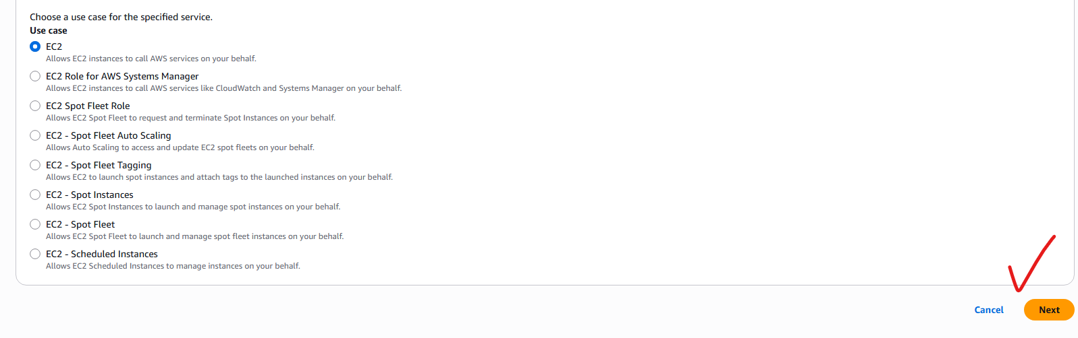

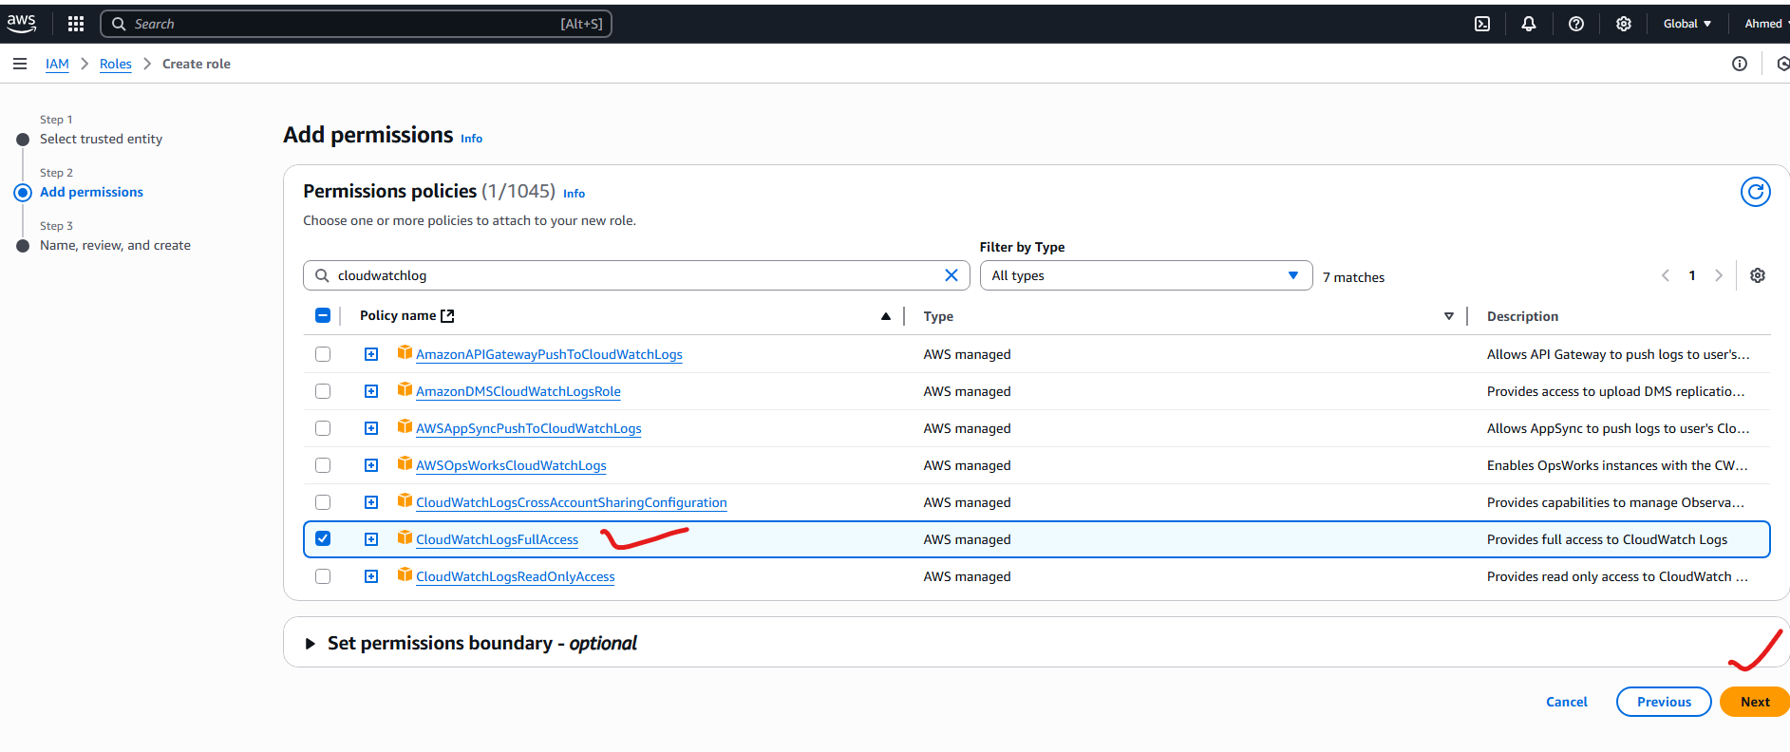

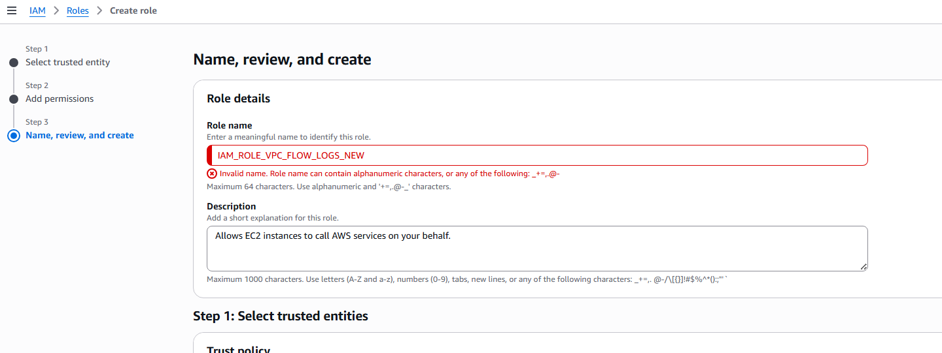

[Iam_flow_log_vpc_new](https://us-east-1.console.aws.amazon.com/iam/home?region=us-east-1#/roles/details/Iam_flow_log_vpc_new)

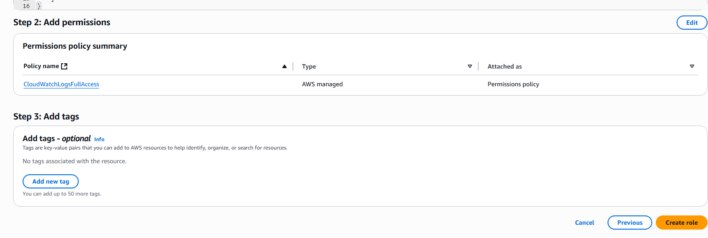

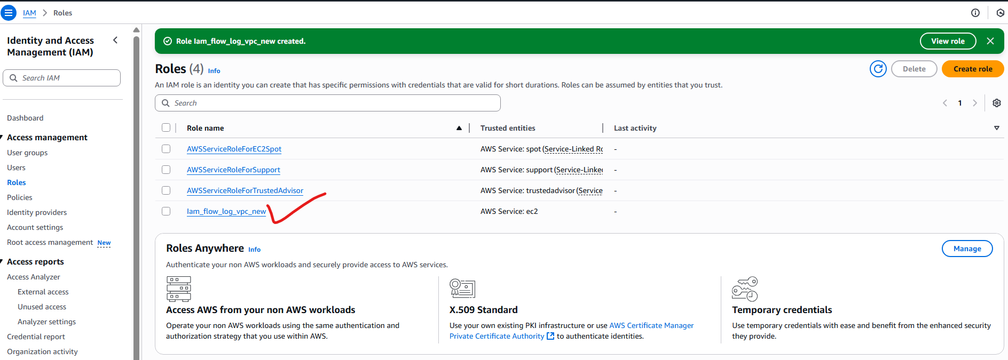

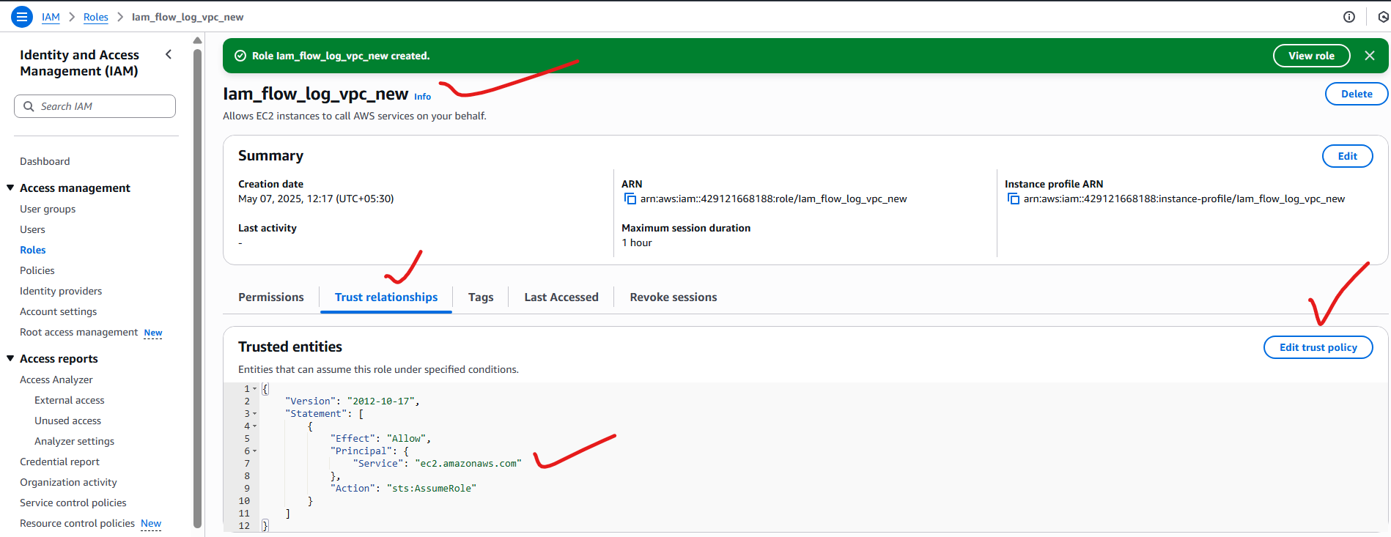

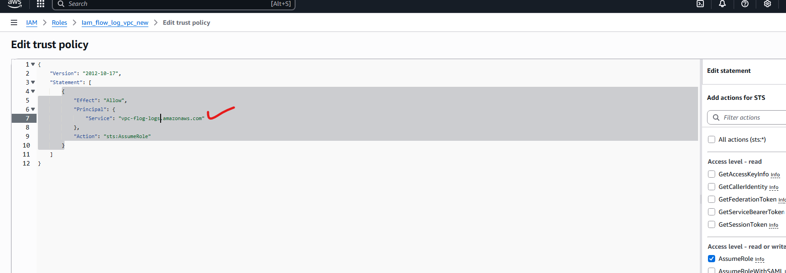

**Change ec2 to vpc-flow-logs in the json script: done below**

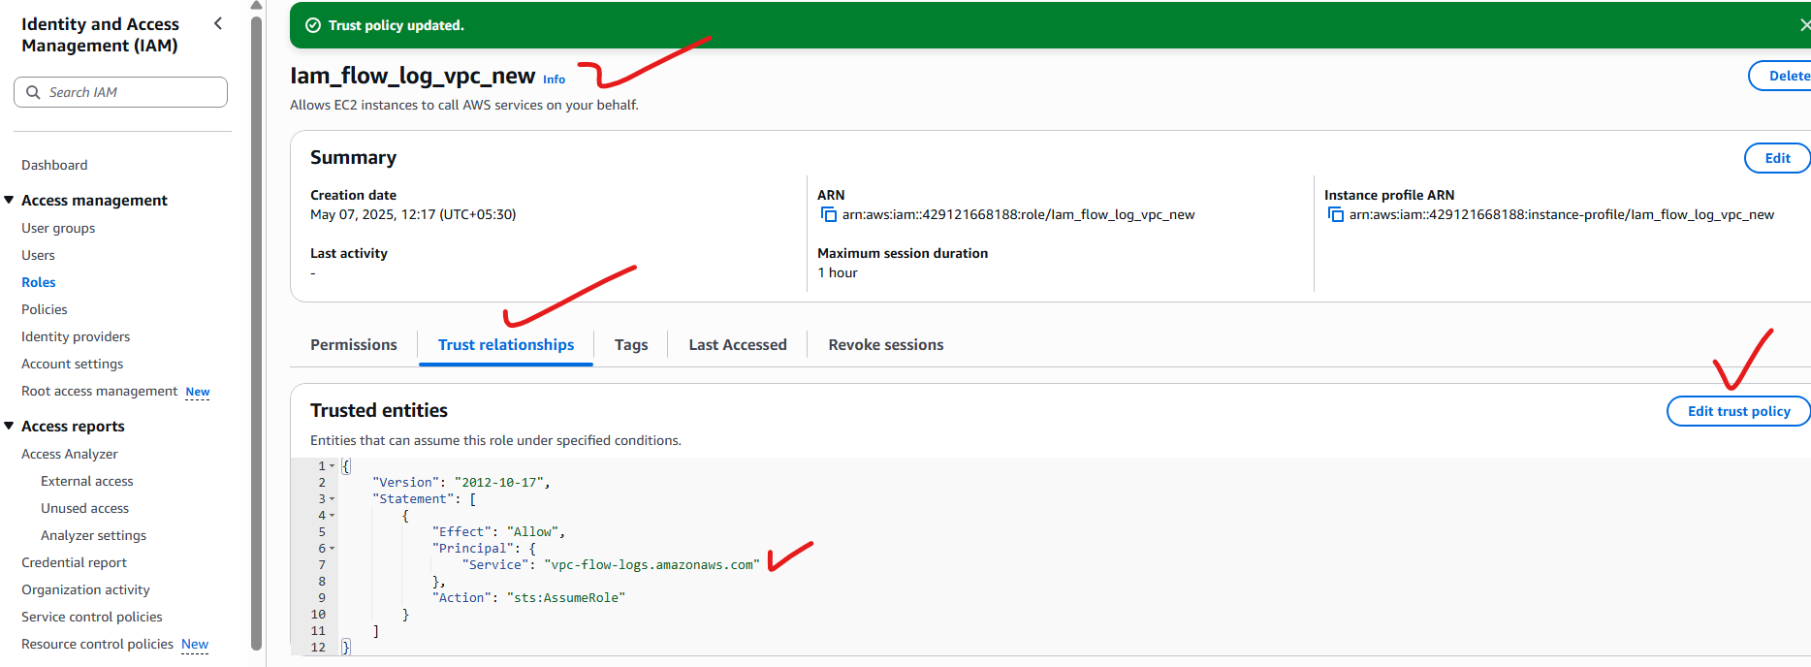

**Step3: jump in to cloud watch service**

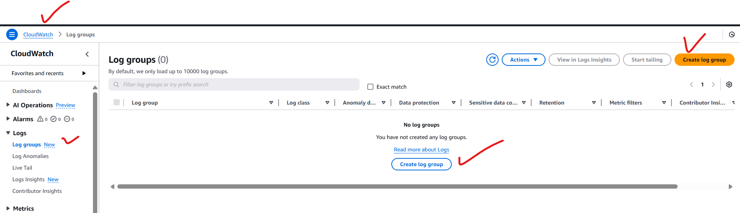

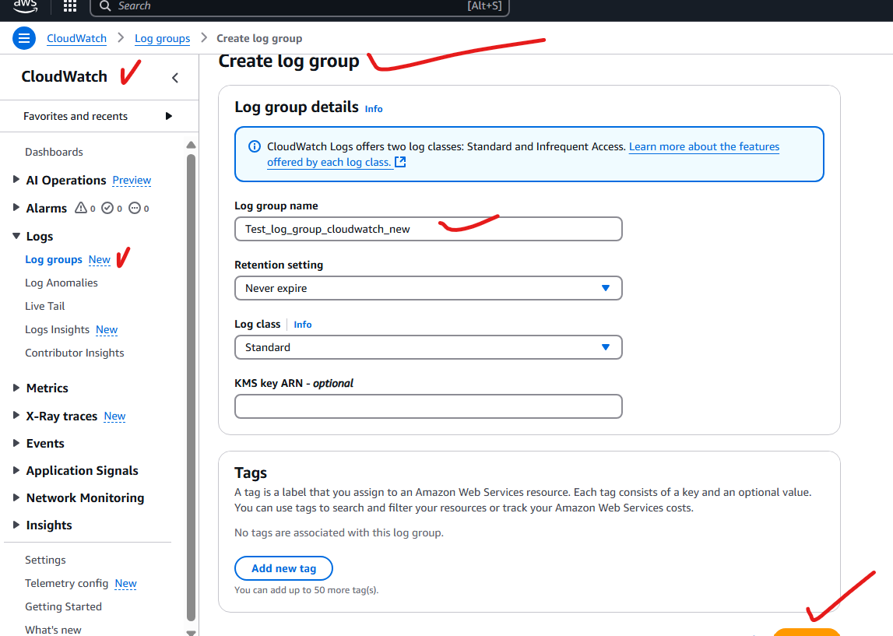

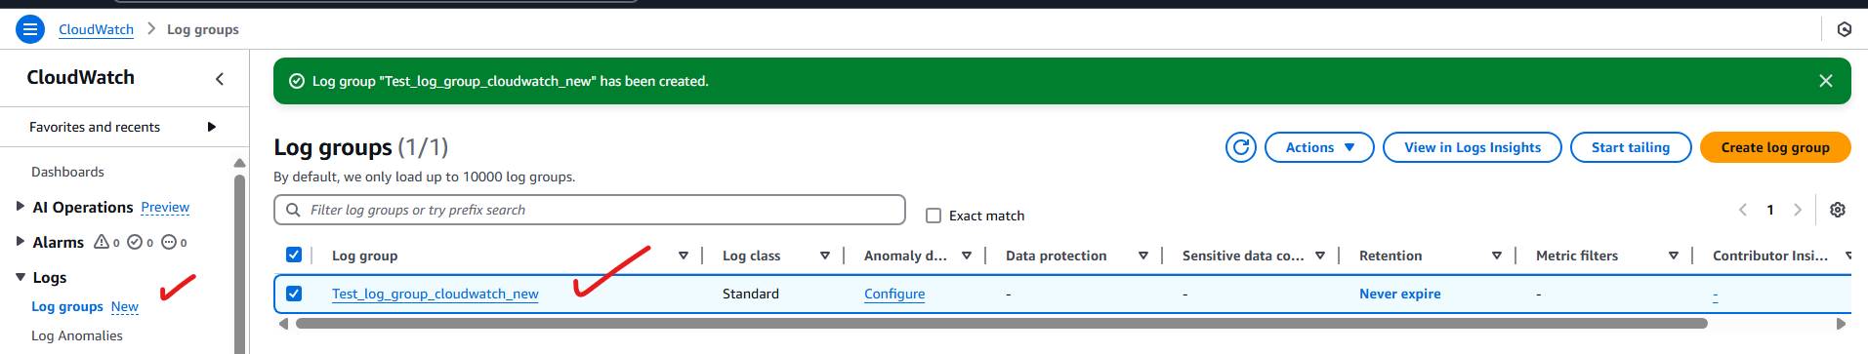

**Step4: Go back to VPC to enable flow logs:**

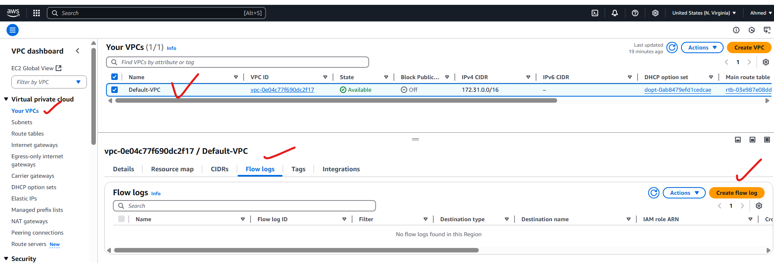

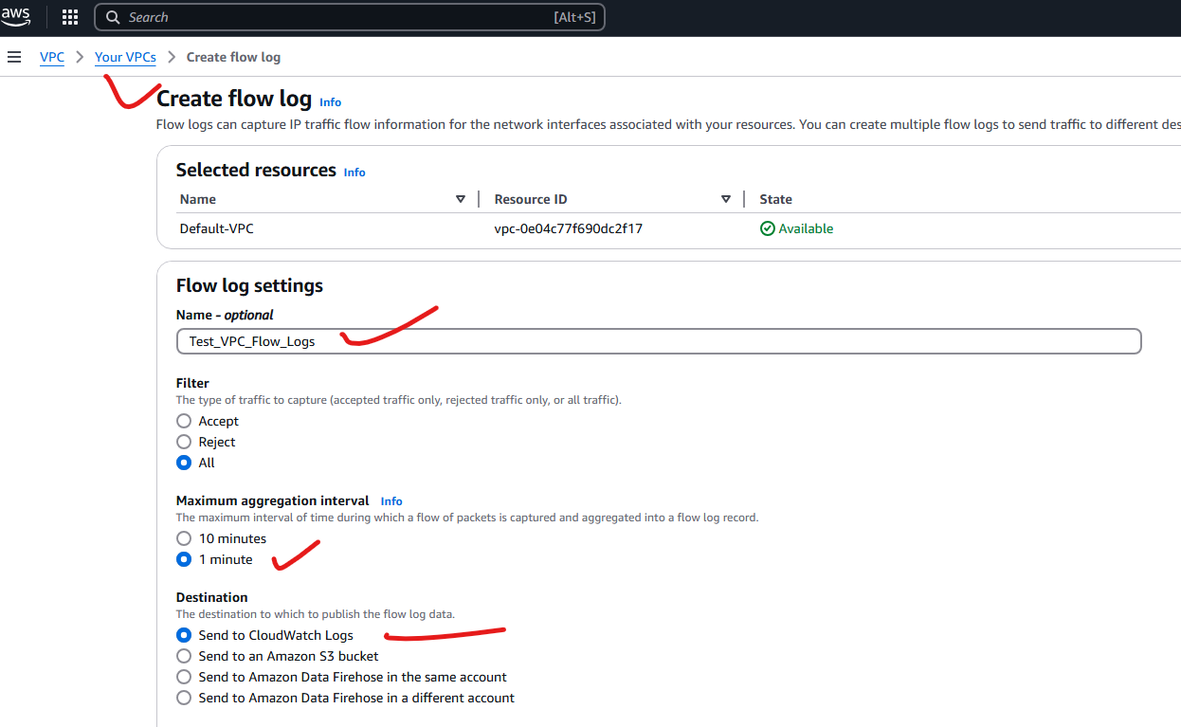

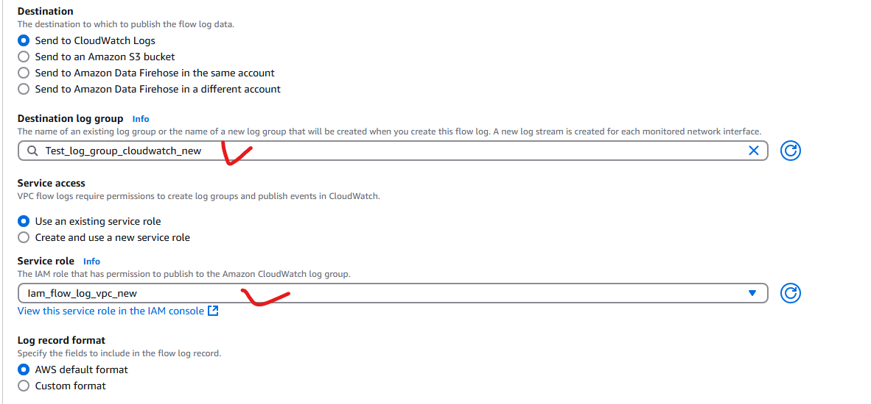

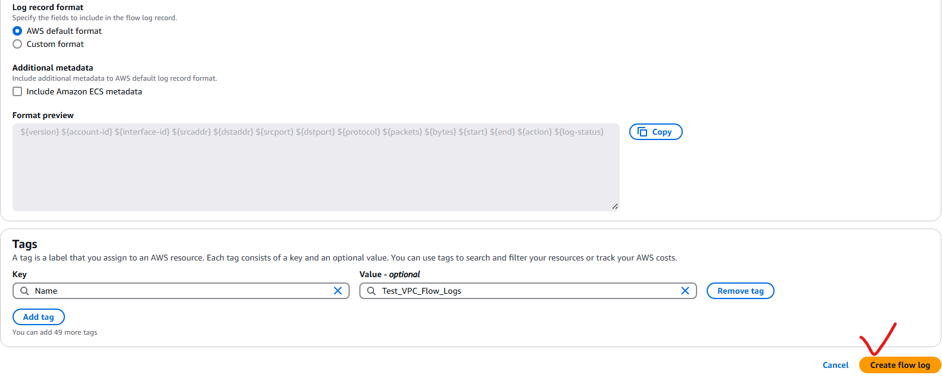

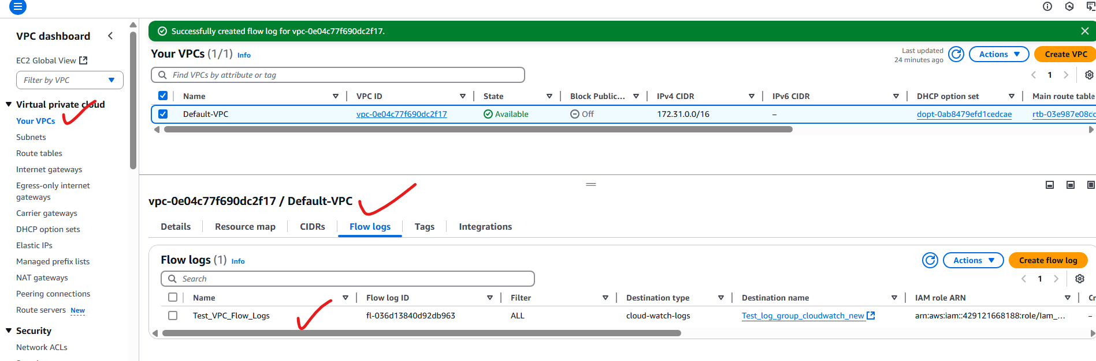

**Step5: move to the cloudwatch service**

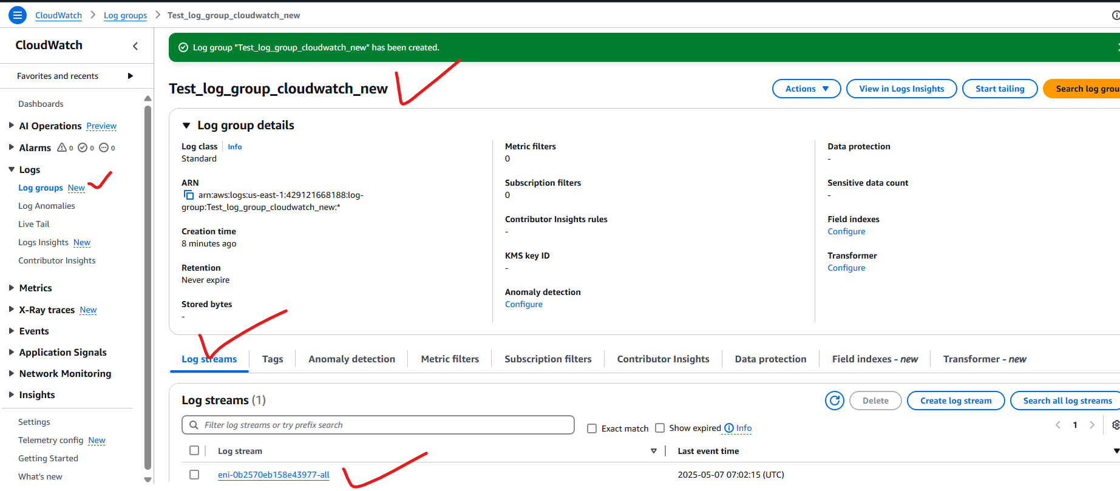

**Step6: copy the public ip of an instance and browse in the internet so that we will generate the logs.**

* **And wait for some time to get logs.**

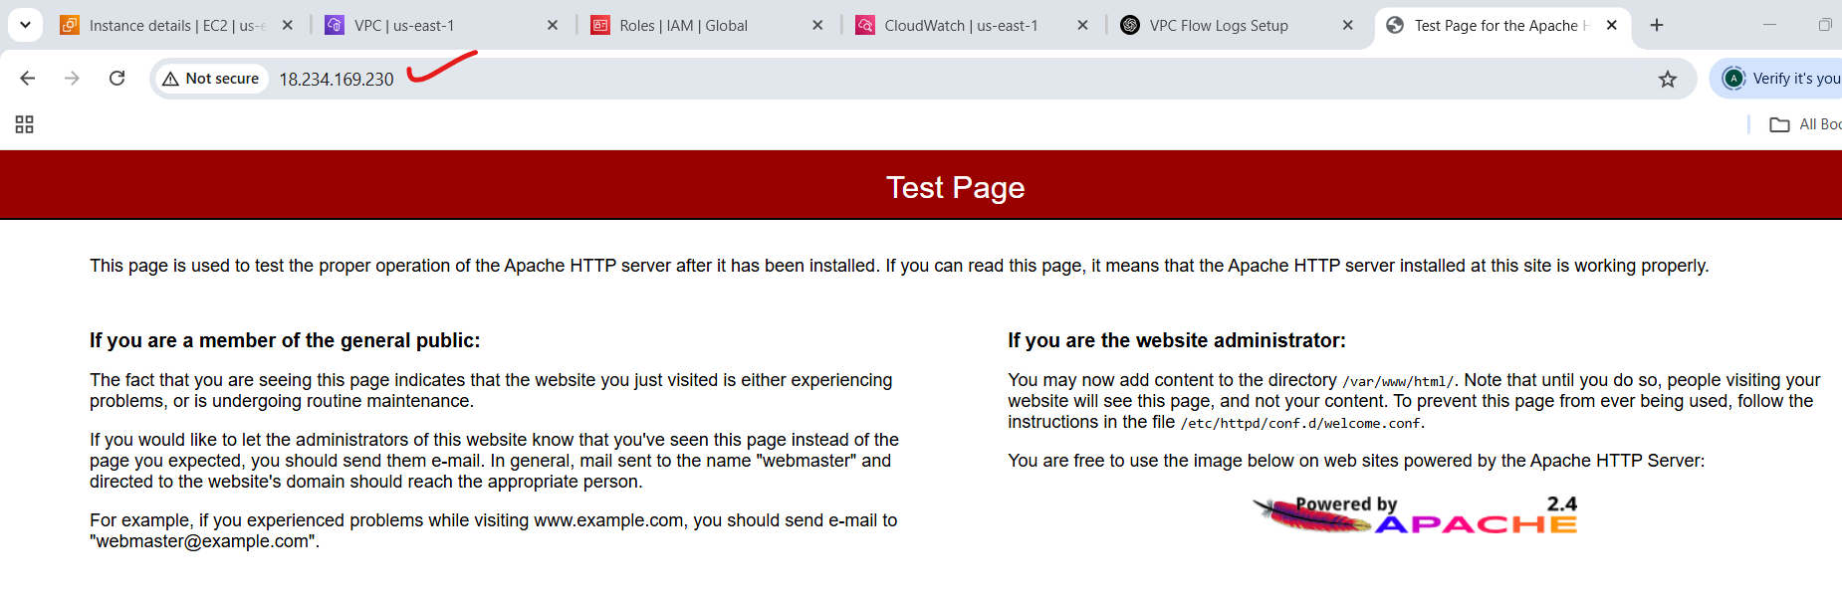

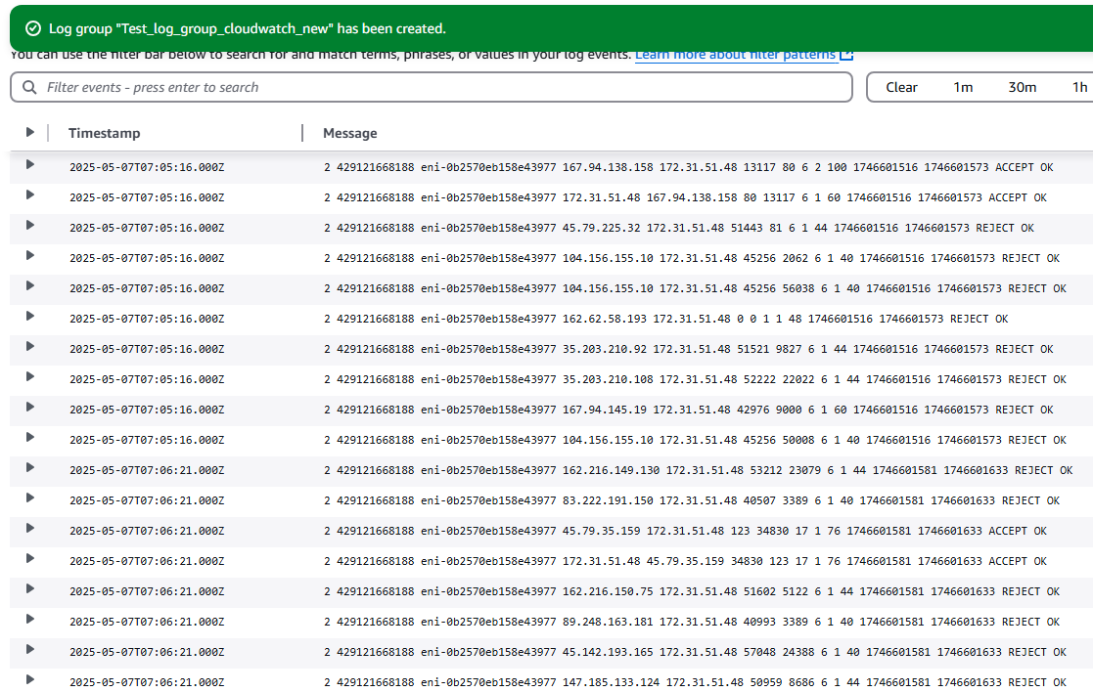

**Storing the VPC Flow Logs in S3:**



